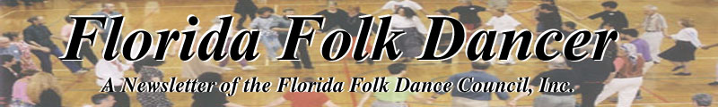
January 2005

FROM THE PRESIDENT'S DESK

My dear Fellow Folkdancers -

The registration forms for Camp (as of 1/15/05) are coming in now fast and furiously (Goody). We are now up to 36 participants! And may I remind everyone that if you sign up for full registration for Camp you are automatically a member - we got your bones whether you want us to or not. On a family membership (two adults living at the same address); if only one of those two members comes to Camp, than an additional 5.00 will be required for membership and to receive the monthly Newsletter. If you sign up ONLY for part-time registration, than your dues are not covered and you will owe us 15.00/20.00 by March 1st, but they may be paid along with registration for Camp, but please state as such on your check, etc. Next year - we should all live and be well - there will be a line allotted for the paying of dues (as was done in the past), but this year - there was just no room (but info on this is on your "red" sheet).
And speaking of Camp - we need workers and scholarship students (all your expenses on campus are paid). So teachers - any student you think worthy, drop me a line and let me know -OR- you may plead your own case. Don't be bashful! Workers must register for at least two full days (6 meals) but scholarship students, for as little or as much as they so desire. The light housekeeping duties are the same for both - cleaning tables after meals, and possibly sweeping a couple of floors, and to help make sure that cabins, at departure time, are left clean. So far, I have only 1 full time worker, and there is room for one more and for 2/3 scholarship students. I have also been getting requests from some who specifically wish to room with certain other people. Although the cabin sign-up sheets are put out on the day of registration for Camp, I have honored all requests and have made temporary sheets to make sure all your desires are met.
Geez! I'm still speaking about Camp, but I have some new, exciting information to share with you. I was contacted by Stephen Spinder from Rochester, New York, but who has been residing in Budapest, Hungary for the last ten years. Stephen is a professional photographer who has devoted most of his work to photographing his first love – Hungarian culture from every ethnic aspect; in song, dance, etc. He has been honored for his work in Budapest and the United States as well as being invited to participate in cultural exchanges between The Netherlands and the Ministry of Cultural Heritage. He will bring his collection of photographs that are also in beautiful book form and may be purchased through Stephen. He will also teach us one Hungarian dance, even though our dance schedule is tight, and am sure he will impart many of his experiences in the folk culture of Hungary.
In March, and in the first Newsletter right after Camp, a full membership list will be published, and if you are not on it, it means you have not paid your dues and will not receive a Newsletter in the future. We are contemplating, however, of just having a mailing list for those who live a distance and don't care to receive a Newsletter, but want to be kept informed about Camp.
We still need a president to list on our slate - will it be you? If so, contact Terry Abrahams who is our nominating chairperson. Don't forget your tap shoes; your copy of FFDC's Bylaws (no extra copies handed out at Camp) and - your happy face!

REALLY see you soon now
- Ann Kessler, President/Treasurer

REFLECTIONS ON DANCE
by Dan Lampert <dan@webuniv.com>

On January 16, 2005, some Israeli folk dancers (who normally meet at the JCC on Monday nights) performed before an audience at the Rosen Plaza Hotel on International Drive. Led by Debbie Meiten, we danced about 7-8 dances, and I captured some photographs while sitting out of some dances.

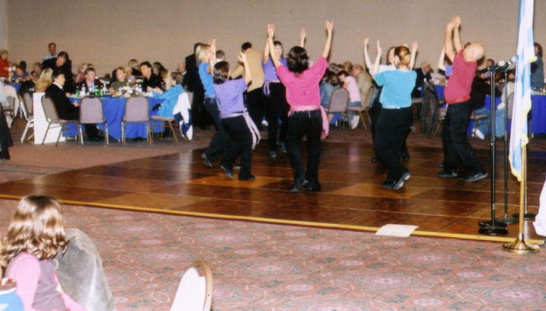

The floor was stable and good. Dancing was easy and we all had a good time. Since we're not used to performing in public, we talked amongst ourselves prior to the show. We were a little nervous, but we resolved: "if a problem or mistake happens, just smile and continue as best as you can." This is a good motto for performers. Besides, each performer should be smiling so the audience can see your enthusiasm.

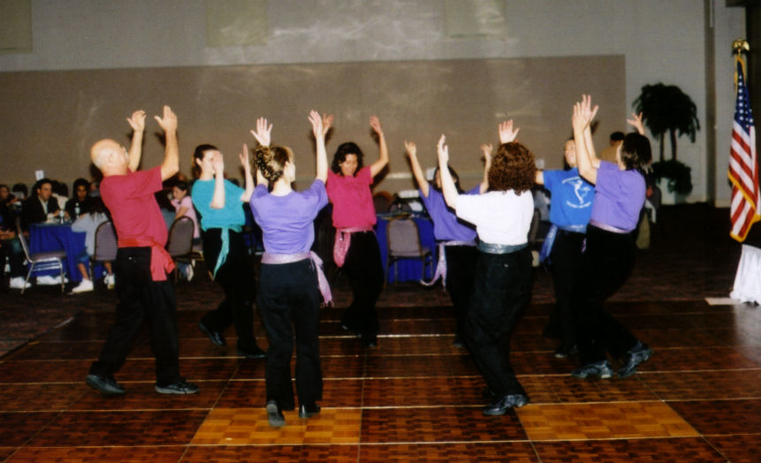

After the performance, one of the arrangers of the event took a moment and photographed us using my Canon T50 camera. Nice old camera! Great picture!!

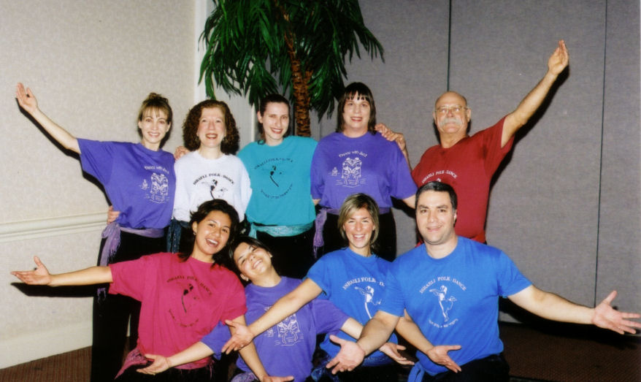Back row, from left to right: Andrea Habitz, Debbie Meitin, Sharon Kalter, Pat Henderson, Bobby Quibodeau. Front row, from left to right: Nashielly Aguilar, Melisa Carmona, Shimrit Barkai, and Dan Lampert.

I look at this group picture, and I remember an inscription from a little book at the end of a famous movie. The inscription reads "no man is a failure who has friends." Do you remember which movie this comes from? The movie was “It's a Wonderful Life” by Frank Capra. At the end of the movie, Jimmy Stewart (playing the lead character George Bailey) has faced great obstacles, including possible public disgrace and financial ruin. However, his friends declare him "the richest man in town". He realizes how important his friends are when a friend gives him a book with this inscription: “no man is a failure who has friends.” And although the movie has nothing to do with folk dancing, think of how many dancing friends and students we have influenced! We are passing on knowledge. We are making this world brighter. We are doing something whose importance reaches farther than we can comprehend.
- Dan Lampert
.........................

KLEZMER HOP in St. Augustine
From Lisa Johnson <klezmom@yahoo.com>

The 24th Street Klezmer Band will be playing at a Klezmer Hop in St. Augustine. Dancing will be taught and led by world famous Yiddish dance instructor Steven Weintraub. The Klezmer Hop is on Saturday, February 26, 2005 at the R. B. Hunt School. This is the time to learn how to dance bulgars, zhoks, terkishers, shers, and more. Call or email Toby for more information. tobistan@att.net (after Jan. 22) (904)471-0418
.........................

NEWS ABOUT HAL SCHMETTERLING
from Jan <amarjan@bestnetpc.com>

Hal Schmetterling was diagnosed with pneumonia recently and has been hospitalized in St. Augustine. He has been undergoing all kinds of tests and has had to have fluid drained from the lungs to make him more comfortable. Unfortunately, today they discovered cancer cells in that fluid. He has an oncologist who will be evaluating him further and will probably have him begin a course of chemotherapy as soon as he recovers from the pneumonia. He will be in the hospital at least through the coming weekend.
His home address is 7 Packard Lane, Palm Coast Florida, 32164
.........................

SOME ADVICE FROM
THE DELAND DANCERS
by Joan Washington wjwread@hotmail.com

We had our Christmas party this year and thanks to Myriam LeMay we chose the theme "socks". Dancers were invited to wear Christmas socks or ethnic socks or any socks that they just thought were special. Let me give you some advice. It's fun to have a theme for the Christmas party and "socks" was a good theme. Now let me give you some more advice. Don't decide to give three prizes for the socks. We had 12 dancers with socks and every one was a winner. What was I thinking? How could I select just three winners? I finally chose Bobby Quibodeaux - Christmas socks with Santa on a motorcycle - Myriam LeMay - Christmas socks with ruffles and bells - and Ava Zamora - Christmas socks with a very interesting design. All three were recipients of the fuzzy sock award. We had a lot of fun dancing, a lot of good food, and a lot of fun admiring all the socks. Happy new year!
--Joan Washington
.........................

ORLANDO INT’L FOLK DANCE CLUB
By: Pat Henderson

It is hard to believe that 2005 is here when it seems like two years ago, we were preparing for Y2K! Anyway, to catch everyone up on the news of the Orlando group actually goes back to last November. Our own Ann Robinson won first place for her ceramics in the annual Great Day in the Country in Oviedo. Then, she was featured in a long newspaper article with pictures in the Seminole Chronicle. (See picture attached). Congratulations, Ann! Those traveling in December included Juanita and Fred Schockey who took back to back eastern and western Caribbean cruises with Holland America. Wally and Joan Washington celebrated their 30th wedding anniversary with a trip to explore Everglades National Park. Their favorite part was Shark Valley. Then Bobby and I took a ski vacation to Alta, Utah in early December. The snow and the skiing was great but we almost went over the side of the mountain when our car skidded. Fortunately, snow on the edge of the road prevented a calamity. In December, we welcomed Annette Brand from Canada and Dave and Cindy Duckworth from Kansas City to our group. We held our annual Holiday party on December 15 with a potluck dinner before we danced.
In January, for the Epiphany, Deane Jordan and Kelly Fagan attended the Diving for the Cross and the Greek Festival afterward in Tarpon Springs. Manuel and Palmira Mora-Valls also attended. Then, in mid January, the Washingtons and Bobby and I traveled to Ft. Myers to visit the Koreshan State Historic Site and the Edison Museum and Laboratory. It was a birthday trip for me. As we approach February, there are many dance opportunities on the horizon: the English Infusion weekend January 28-30, John's birthday-workshop weekend February 4-6 and then camp the last weekend in February. We, in Orlando, look forward to seeing many of you again at one or more of these upcoming events.
.........................

DANCE YOUR WAY THROUGH
THE GREEK ISLANDS IN 2005

This year, there seems to be plethora of folk dancing seminars on the Greek islands. Attending one or more of these seminars is quite an experience, since, in many cases, the lessons are taught in a foreign language. This usually doesn't present a problem to most experienced folk dancers, since watching the teacher and listening to snippets of English translations seem to be sufficient to learn the dances.
What is so wonderful about a foreign-based seminar is that you will be dancing with people from all over the world. There are large numbers of French, German, Japanese, Dutch, Israeli, and Australian travelers, just to name a few, that frequent these seminars. You realize very quickly how folk dancing itself is an international language! No matter where you are dancing in this world, you will be communicating with the person(s) standing next to you. You will learn that there are no strangers when you are holding hands and dancing.
Below are just a few of the folk dance seminars being held in Greece this year. I selected them because they are all being held on Greek islands, which are lovely settings in which to relax, have fun, and DANCE!
Ikaria, Greece april 28 - may 6
Contact: Christiana Katsarou (french, english), Christiana_katsarou@hotmail.com
Kalymnos, Greece july 24 - july 31
Contact: Hélène and Jean Maris (french, greek), kalymnos1@wanadoo.fr
A week in Paros, Greece may 28 - june 4
Contact: Kathryn Penny, Kath.penny@tesco.net
Andros, Greece july 12 - july 21, 2005
Contact: panagiothsp@hotmail.com (greek, english)
Island of Crete (2 weeks) - Mazoxi 2005 july 14 to july 29, 2005
Contact: Athan Karras tel (818) 609-1386, e-mail: mazoxi@prodigy.net
EPIPHANY DANCE EVENT
by Manuel Mora-Valls ctismm1@ocnjcc.org

We (me and wife) went to Tarpon Springs for "Epiphany", on Jan 6th. Kelly and Deanne were already there. They came the night before.
Nikos, the old guy from Orlando, was also there.
As we had a little trouble with my car getting to Tarpon, we were not on time to see the "diving for the Cross", but Kelly and Deanne
saw the show.
We got there on time to dance for a little less than three hours, no interruption. Performers danced at the beginning, and the band
was not interrupted afterwards. The whole festival ended at around 6:00 PM. The band was a "non-stop" for those three hours, playing a good variety of songs, announcing the type of song they would play next, with a lot of people dancing. That part was GREAT! To be fair,
the event also had pricey food and wine, and the dance floor was concrete. Overall, the music was the best part of the event.
.........................

SCANDINAVIAN WORKSHOP
from jdaly@palmnet.net

The South Brevard Dancers are busy preparing for the Scandinavian dance workshop in honor of John Daly's birthday (we won't mention which one). We've arranged for Roo Lester and Larry Harding to come down from Chicago to conduct the workshop along with Becky Weis from St. Paul to provide music on Nyckelharpa and fiddle, so there will be excellent instruction and great music.
The workshop will be on the wood floor in the Historic Community of Melbourne Village, Florida. This is the same location as the last Fall Fling and close to the Village Hall where we have held Fall Fling and our January parties for many years. So if you've ever come to one of our happenings, you'll know how to find us. If not, there are driving directions on the flyer included in this issue and on the website (www.folkdance.org).
The floor is not as large as we'd like, so for this workshop we're limiting attendance to about 30 people. To insure a space, please register in advance. We'll try to accommodate more if they show up, but people with reservations will get priority if the floor gets too crowded. Call John and Barbara Daly (321-951-9623) or Jean Murray (321-952-7025) or email jdaly@palmnet.net. to register or get more information.
There will be no admission fee as such. Contributions will be accepted and if enough people choose to contribute about $10 per session we may do more Scandinavian events. But it is a party, no one will be counting. We're just going to have a good time learning lots of great dances.
.........................

INT’L FOLK DANCERS OF COLLIER CTY
by Helen Marks

We would like to invite FFD Members to visit our group. Please see the included flyer for our dance schedule.
On February 12 & 13, the Greek Orthodox Church will have a festival which, in the past, has been terrific! Over 1,000 people attend. There has been a fine live greek band from Ohio. More than 20 of us crowd around a banquet table in a huge tent. We dance on the ‘black top’ dance floor from 1-4 PM. School children perform in authentic costumes from various areas of Greece and Macedonia. The food is great!
The Festival will be held at: St. Katherine Orthodox Church, 7100 Airport Pulling Rd., N. Naples., Ph: 239-591-3430. The church is on the east side of the street. Park on the West side and catch the shuttle to the festival.

GREETINGS FROM GAINESVILLE!
by Raluca rarosca@ufl.edu

Somebody asked why I am not sending news to the newsletter anymore. Well, what can I say in my defense if not 'my work/life is interfering with my dancing'? Plus, my present appointment is ending in May, so I'm looking for a new position, etc, etc.
However, since I've last wrote, the folkdance in GNV has been doing reasonably well. We had a very good performance on Nov 14, as part of the International Potluck , thanks to Max& Diane, Jack and Linda, John, Becky& Alex, Stefan, Josan, Jenneine, Julieta, Tina and Misha, Mary-Jean and Bill who come and helped with the demonstration. After a few dances wasted on the audience (80 people or so), we put on Pata-Pata and voila! we had a few people dancing w. us. We finished triumphally performing Rustemul--that was after we've joined in the Lebanese Debka (once a dancer, always a dancer--the guy leading the line was too good for us, but we followed very well his friend, the second in the line).
Around Halloween we've moved our music cabinet in Weaver Hall, so we have now in there all our tapes, CDs and MP3s. We are back to the Norman Hall routine of pushing the cabinet around (this time is out of the office, in the elevator, out of the elevator and toward the rec room) but things are going pretty smoothly. We've seen some new dancers toward the end of the year, thanks mostly to Radha Sylvester, a fan of Israeli dance in her youth years and a Girl Scout Team leader in her present ones.
Let me see, what else? We had a 'Romanian Folkdance' impromptu moment for December 1st, the National Day of Roania. Margaret joined Raluca and Stefan (our student/treasurer and a faithful recruit) at the exposition organized by the Romanian Student Association at Reitz Union, and you can see the results in the picture!( Ciuleandra and Hora Spoitorilor were two of the 10 or so dances tried that day).

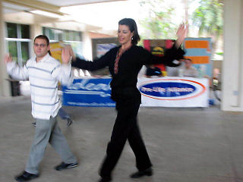

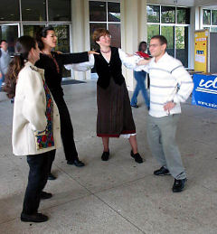

Other news from people who keep me in the news loop: Yang Mu defended her Ph. D. dissertation; Josan is visiting his parents in Punjab for the holidays; Shelley sends her regards from Washington, where she now lives/works and reports seeing Nicole, once our club president; Margaret had her painting installed in the new Orthopedic center open in GNV and of course, yours sincerely is a first time aunt.
I was ready to wish you happy holidays and go caroling, but I have to mention 3 more parties: 2 past successes (Lake Wauburg Cypress Lodge on Dec 12, Julieta's house on Dec 19--thanks Bob and Pat for joining) and a future one (Julieta's house on Dec 31st). If you are on our Gainesville email list (folkdanc@lists.ufl.edu) you've probably heard about those (unless you have an aol address, which doesn't like ufl addresses, don't ask me why).
Well, this being said, I wish you all the best in the New Year and I'll see you dancing!
Raluca

TACOS for TERRY
Ola everyone! I'm back from Mexico. As you remember from last month, I went with Ginger that used to dance with us and she and her new husband were perfect "hosts", and the guide was beyond great (he is the official National Geographic guide - what does that tell you? - and an old old old friend of Ginger's); there were only 9 of us, counting Ginger and Nick and the bus driver and Juan the guide. So we tootled around in a van, saw 10 different sites of pyramids, etc. including the obvious Chicha Nitza, spent a night in a village, eating tortillas from their little fires and sleeping in hammocks, and I even convinced Juan and Ginger that if I didn't see folk dancing I would die, so they found a restaurant that had a folkloric show, which was very very nice, and I was very very happy. We ate great meals at all times, and even though Mexican isn't my favorite, it got to be really good! Much better than in the states. The group was very gregarious and on NY's Eve we sat around our table, drank margaritas and champagne and had a good time - for once I wasn't at a contra dance, and loved it!
Enough about me. What about YOU? Are you going to be the next president of the Florida Folk Dance Council? Have you forgotten to call me? I'm waiting....camp is coming soon....
Our club is per usual. Ursula back from a trip, ready for another, but she has to write her own, and since she doesn't, guess you don't get those details. Many of us are gearing up for the Snowball next weekend. I'm having printing trouble, so way behind on the buttons. Some of us are also looking forward to John's big weekend. Should be great! It would appear I don't have anything to say this month, so I'll say Adios and see you at camp! --Terry Abrahams

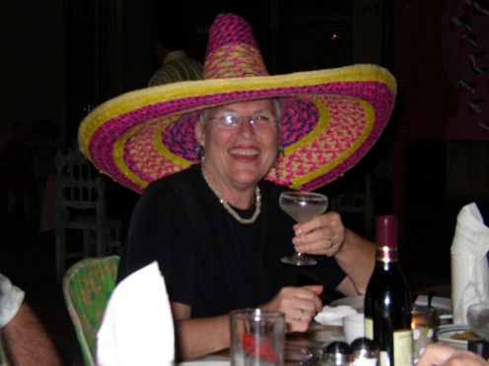
Terry in restaurant watching dancers with "guest" sombrero
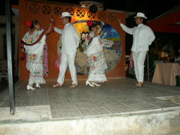
Folk Dance performance
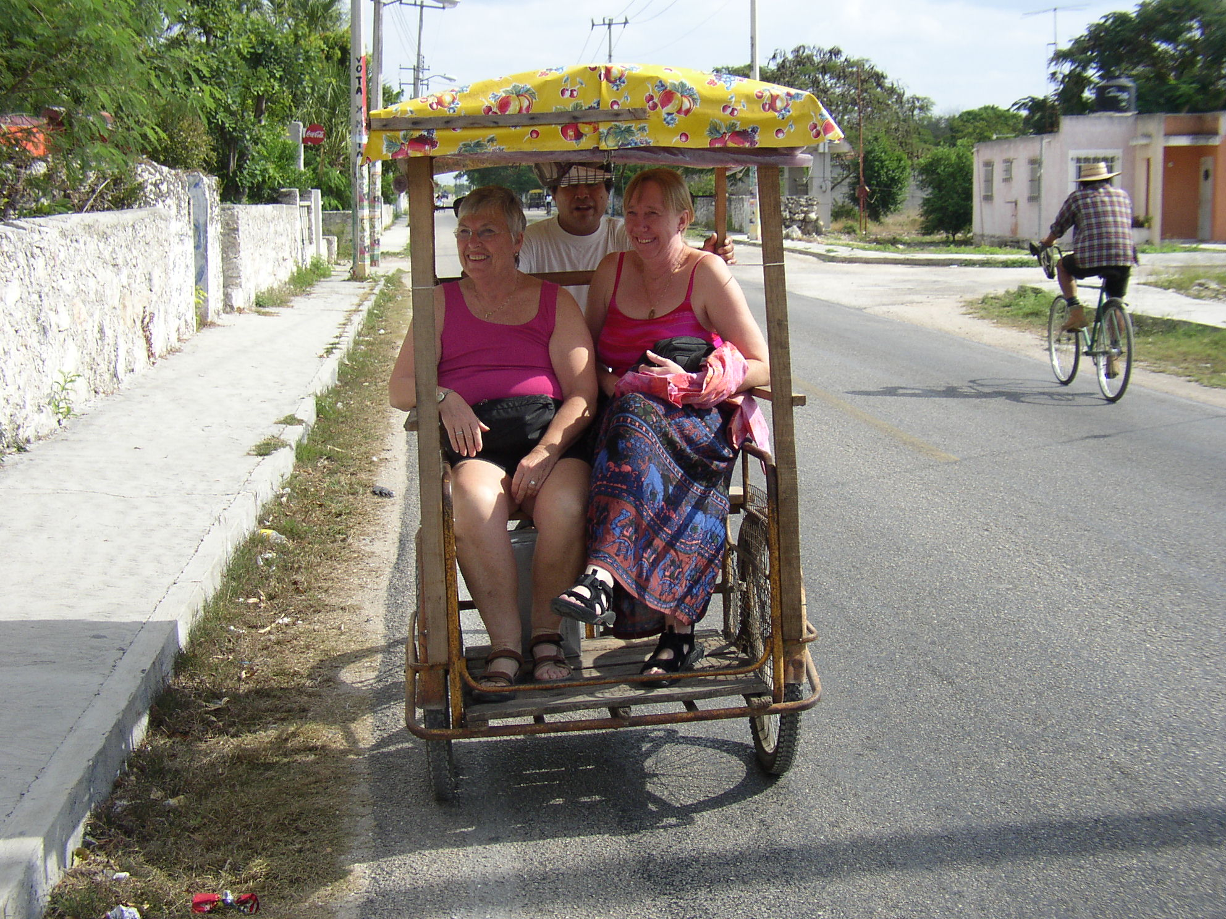
Terry and Ginger in taxi in village
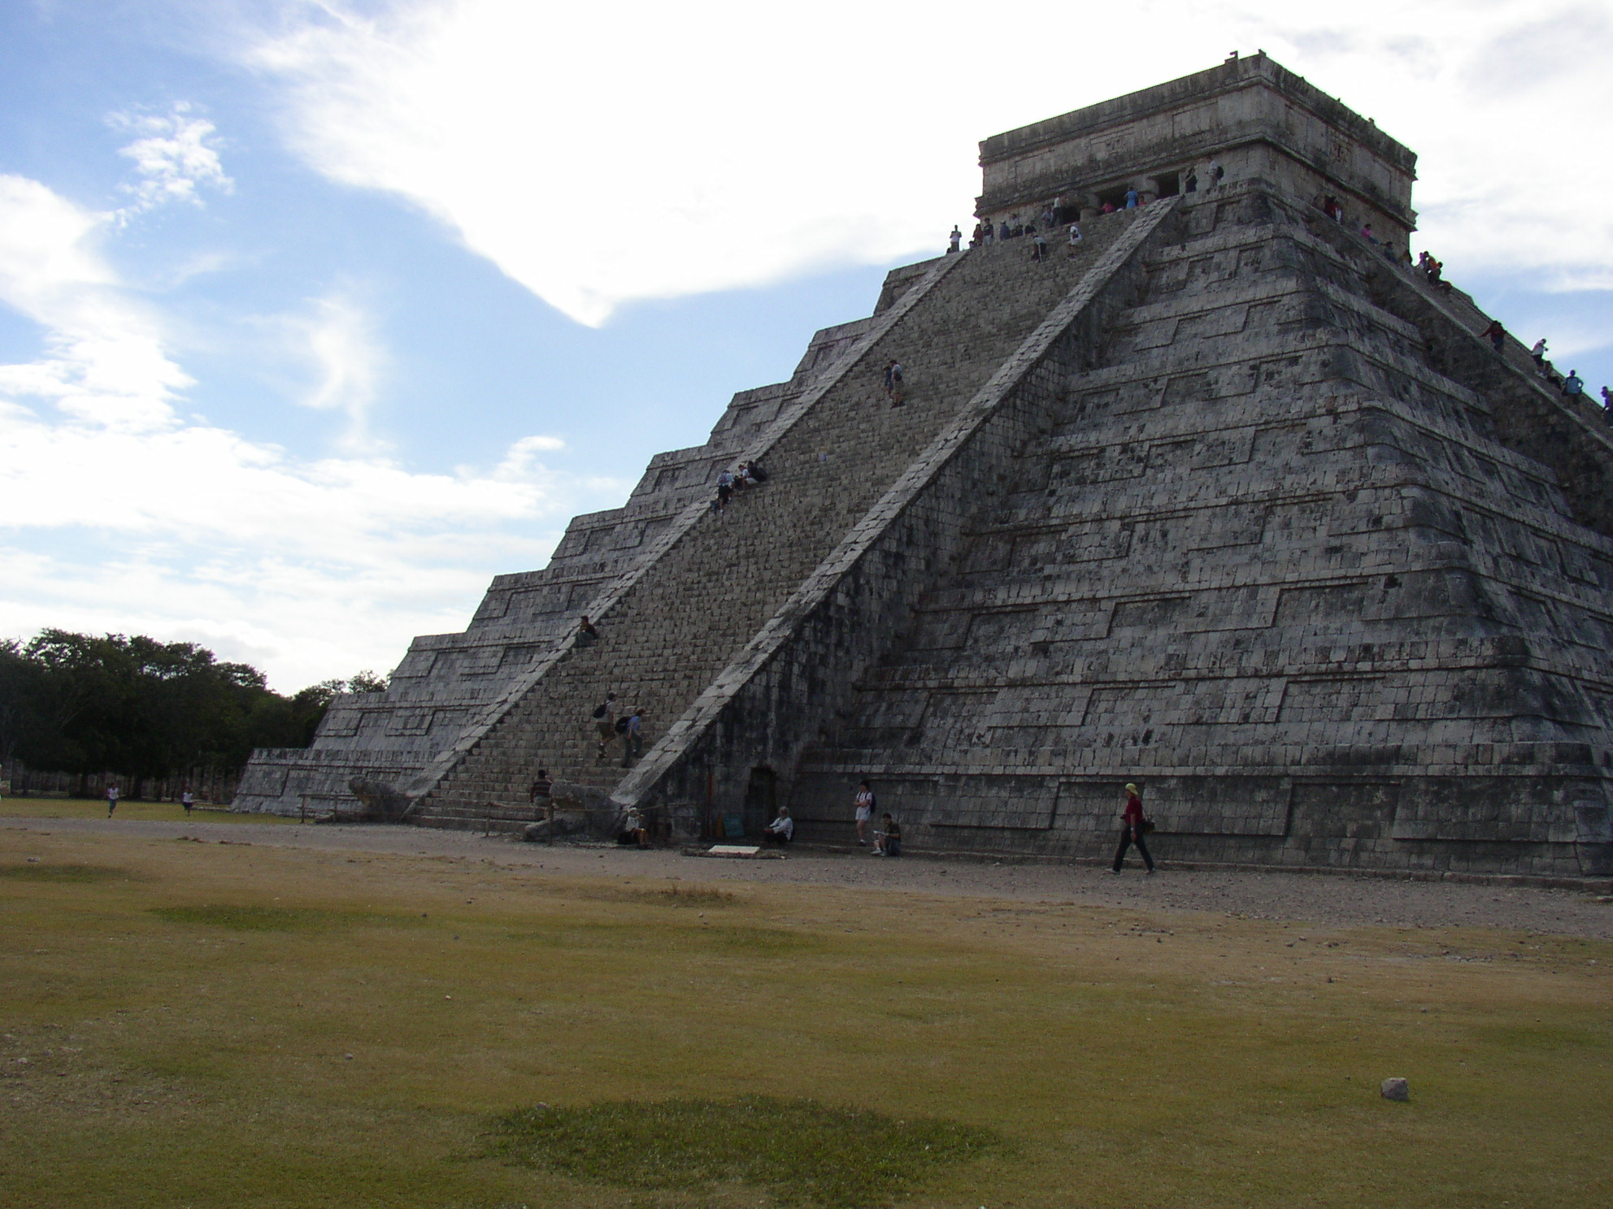
Pyramid at Chichen Itza
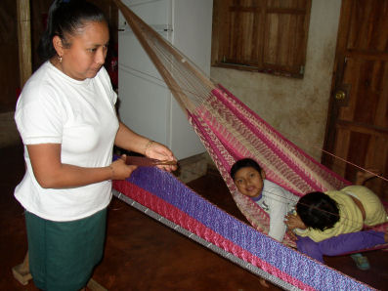
Native weaving hammock - children watching
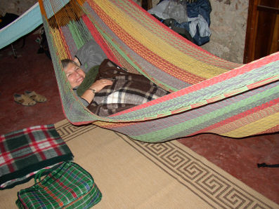
Terry getting ready to spend the night in

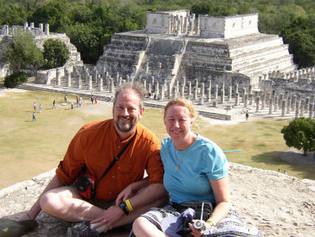
Ginger and new hubby Nick at Temple of 1000 columns at Chichen Itza

FLORIDA FOLK DANCER

Florida Folk Dancer is a monthly publication of the Florida Folk Dance Council, Inc., a non-profit corporation whose purpose is to further knowledge, performance, and recreational enjoyment of International Folk Dance.

President: Ann Kessler
3295 Gorse Court
Palm Harbor, FL 34684
Phone (727) 789-6480
annie8@aol.com

Editor / Dan Lampert
Historian: PO Box 151719
Altamonte Spgs., FL 32715
dan@webuniv.com

VP/Sec: Nancy Wilusz
3880 El Poinier Court
Sarasota FL 34232
edwardnan@webtv.net
-

Return Address
FFDC Newsletter Editor
Post Office Box 151719
Altamonte Springs, FL 32715-1719
USA

Please circle your calendar for our camp’s weekend ... February 25-28th, 2005

FIRST CLASS

Committees: Advisors to the Board:
Pat Henderson; 407-275-6247
henderp@bellsouth.net
Terry Abrahams; 813-234-1231
terry.abrahams@verizon.net
John Daly; 321-951-9623
jbdaley@compuserve.com

Nominating Committee:
Terry Abrahams

Send all submissions to the Editor when requested by email reminders.
Copyright: articles in the Florida Folk Dancer are copyright by the Florida Folk Dance Council, Inc., or by their individual authors.
Subscriptions are $15 per year and include membership in the Florida Folk Dance Council. The membership year runs from one Annual Camp (usually February) to the next. Members can receive the newsletter electronically if desired.
For more info: www.folkdance.org

