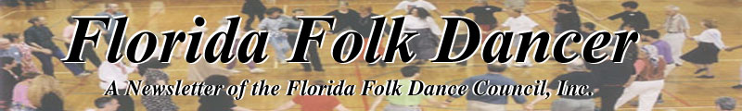
February 2005

YOU CAN STILL REGISTER FOR CAMP!

The camp registration deadline (for normal prices) is past, but you can still register for a few dollars extra and go to camp. Take the form (enclosed with this newsletter, or see the web site) and fill it out right away. To make sure it's received ASAP, you should fax a copy to me and then mail the original to Ann Kessler.
#1 - Fax a copy to Dan at 407-327-2664
#2 - Mail the original with payment to Ann Kessler, 3295 Gorse Court, Palm Harbor, FL 34684
If you have questions, please don't delay. Call Ann at 727-789-6480 or call Dan 407-327-7000 x100.

-- Dan Lampert, Editor

------------------------------

YOUR SLATE OF OFFICERS FOR 2005-2006

PRESIDENT: Terry Abrahams
VICE-PRESIDENT/
SECRETARY: Nancy Wilusz
TREASURER: Ann Kessler
EDITOR/HISTORIAN: Dan Lampert

- Ann Kessler

------------------------------

REFLECTIONS ON DANCE
by Dan Lampert <dan@webuniv.com>

In past issues, I've written about the many positive aspects of dancing. Some of the highlights are the fun, the activity, and the sense of community. Well, one of Orlando's jazz / ballet teachers, Dario Moore, believes strongly in the "community" aspect of dance and has taken this to a new level.
Dario Moore is someone I've written about before. In 2004, he choreographed a stage performance by fusing jazz dance and african folk dancing. This caught my attention because noone else had ever done that to my knowledge. And just recently, I was invited to see "Faces of God", his second choreography, which was performed in February 2005 in Maitland, Florida. It sounds religious, but it's not. The sets were very exciting, the dance was expressive, and once again there was an African influence on the jazz / ballet performance. But here comes the "community" aspect… the two hour performance tells the story of five inter-connected lives in a city. Of course, the "telling" is completely through dance. There's no dialog. What a challenge! However, Mr. Moore has done a very fine job.

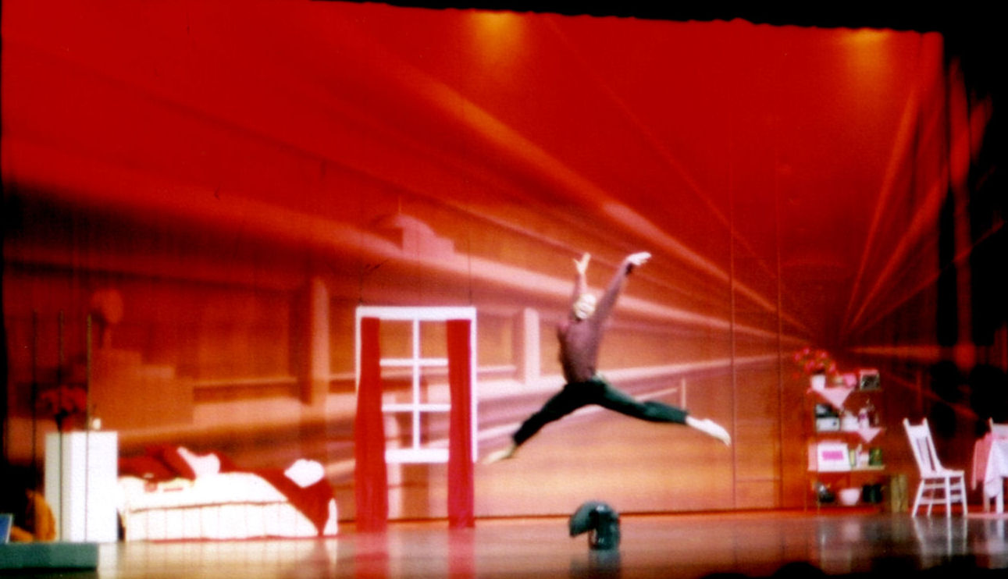One of the dazzling sets of "Faces of God", and here, Dario Moore "the salesman" is leaping in the air.

"Faces of God" is not a religious performance. It's the story of inter-connected lives, and will be presented again in April 2005 in Maitland Florida. See Mr. Moore's web site for info: www.U-TurnDance.com

BEYOND MY WILDEST DREAMS
by John Daly <jdaly@palmnet.net>

South Brevard's first Scandinavian workshop was a first class birthday present. I had expected three, maybe four couples. Instead as many as fourteen couples gathered on the floor for workshop sessions. Roo Lester and Larry Harding, with live music by Becky Weis, began Friday evening with some simple group dances. By noon on Saturday we had progressed through several friendly but easy couple dances and practiced many techniques to enhance everybody's skill at turning as a couple. Sunday morning we worked on more challenging dances such as Polska fran Boda. The afternoon was devoted to a review and then Becky Weis conducted a workshop for our local musicians.

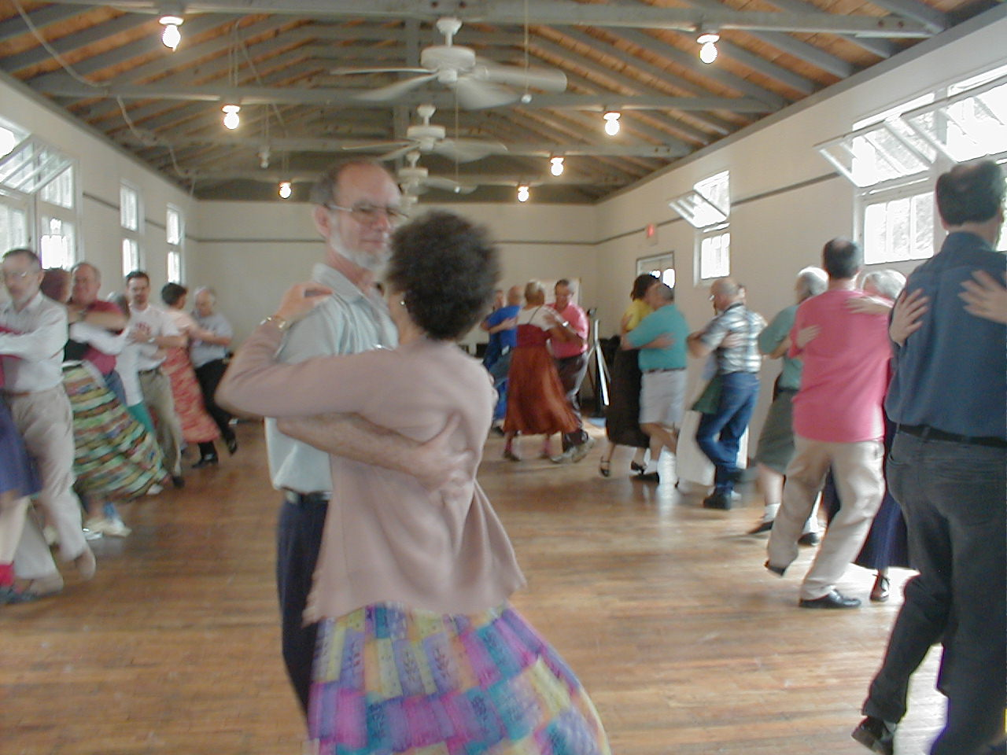

This was our first workshop on the wood floor in the newly renovated Community House. The room is a bit narrow (only 20') but it worked fine at Fall Fling and equally well for the workshop format.
Did I mention food? We had planned on everybody just going out to local restaurants for meals and we would provide snacks. Those snacks soon blossomed into full meals. Our "Prelude" with coffee became a full breakfast, and morning snacks acquired the nature of a full lunch featuring pickled herring, salmon souffle, Swedish meatballs, venison chili, spicy beets, and Shrimp Special followed by birthday cake and ice cream. Sunday breakfast saw potato casserole and Swedish pancakes. The hard work of our many volunteers, especially Chun-Ni, Willa, Fannie, Bernice, and Barbara, earned many compliments from our out of state and international visitors.
Thanks to all who came and all who encouraged and especially all of my friends who contributed so generously. Thanks also to Roo, Larry, and Becky for bringing this exciting music and dances to our community.
John and Jean have promised to continue with Sunday afternoon practice sessions so look for more information as our plans mature.

------------------------------

FOLK DANCING IN FROSTPROOF?
by Caroline Lanker <ctlanker@direcway.com>

We are trying to get folk dancing started in our area. We built a house out here in the country, with a dance room above the garage. The floor is still unfinished, but it's WOOD.
We have been have been having dancing here as often as we are able. Last summer, we had two planned dance parties cancelled by hurricanes Charley and Jeanne. Some local people have danced here several times. They're all beginners, although some are starting to remember dances. We have also had dancing friends from farther away join us on occasion. In January we had a dance attended by 21 people, including 8 kids about 10-14 years old!
We try to dance at least once a month on a Saturday. Our usual format is a potluck supper followed by dancing. On request, we will also do intermediate and advanced dancing in the afternoon, before the supper, for the benefit of experienced dancers. We don't have a set schedule for the spring, yet, but several dates in March and April are possibilities.
Our house is on Lake Reedy, about 5 miles east of Frostproof, which is in the middle of the Florida peninsula, a few miles south of Lake Wales. We're 10 miles south of SR 60, 40-45 minutes south from the intersection of I4 and US 27, 1 1/2 to 2 hours from Tampa via SR 60, 2 hours from Melbourne, 1 1/2 hours (or more if traffic) from Orlando. If any Florida dancers would like to take a nice drive in the country, with a good meal and dancing, please contact us for dates and directions. There's no admission charge, but please bring a dish for the potluck.
-- Gary and Caroline Lanker phone: (863) 635-9366
1963 S Lake Reedy Blvd., Frostproof, FL 33843-9228.

------------------------------

GOOD GIRL-SCOUT TRIP TO NEWBERRY
by Raluca <rarosca@ufl.edu>

Still recovering from the fun of the Friday's workshop, on Saturday I headed to the American League Hall in Newberry for the Alachua County's girl scouts World Thinking day Dance party!
There I've met John & Becky Ward and TIna & Andrew, who took time from their weekend to help with this event. Great thanks are also due to Max for producing the music Cd.
Some 85 girls in (true or make-believe ethnic costumes) were waiting for us. Radha got them moving with the 'Bunny hop' , then introduced us. With breaks for doll-making and sneaks, we taught: Zumpa Ondo, Savila se Bela Loza, Yolanda, Pata Pata,,D'hammerschmiedt gesseln and Mana Vu, and Radha finished the program with the Mexican Hat Dance.
Parents and girls danced together and 'a good time was had by all'. And hopefully all girls will remember the event well enough so to come look for us when they get into UF, years down the road :)

See you dancing as well, sometime soon, -- Raluca

------------------------------

HUNGARIAN FOLK DANCE WORKSHOP

The Csillagszemu Dance Company, with Sándor & Böske Timár, will conduct Hungarian folk Dance Camp this year.
Date: July 24-31, 2005
Location: Sarlóspuszta-Lovastábor (Sarlóspuszta-Riding Camp) Hungary
Housing: hotel rooms with 2, 3, or 4 beds and with bathroom.
Food: breakfast, lunch, and dinner
Recreational facilities: Swimming pool, Jacuzzi, Horse riding, Fitness room
The program each day:
9 a.m. - 13 p.m.: Practice
13 p.m.: Lunch
13 p.m. - 15 p.m.: Free time
15 p.m. - 18 p.m.: Practice
18 30 p.m.: Dinner
20 p.m.: Watching videos, Mr. Timár will give a lecture, or hold a dancehouse
Dances to be taught:
Hevesi dances (North-East-Hungary, the area of Mátra)
Karikázó, verbunk, lassú és friss csárdás
Lorincrévi dances (Transylvania - South-Mezoség)
Pontozó, szegényes, karikázó, lassú és friss csárdás
And review of some other dances...
Price: 90.000 HUF With $1 = 180 HUF, price is approx $500 plus airfare
Registration: info@csillagszemu.hu
Registration deadline: 2005.03.30.
You can get additional information by e-mail from above
or from Julius Horvath at 386-252-5738 or julhorvath@aol.com.

------------------------------

ROMANTIC COUPLES DANCE
IN GAINESVILLE
by Raluca Ioana Rosca <rarosca@ufl.edu>

Well, well, we've done it again! The Gainesville International folkdance club hosted a great Romantic Couple dances workshop on Feb 11, 2005 and it surely was a success.
You don't have to believe my word, here are the details:
-thanks to Yang Mu's announcement to the Chinese email list, to an (welcome but anonymous) announcement to the Gainesville Sun's Scene and to 'my' cherry fliers we had 32 people in the room, 16 of them totally new to the group!
- Margaret was the main instigator of this event; she also designed fliers, organized instruction and put signs around on the workshop day (and also brought drinks and snacks! hats off to Margaret)
- John Wards and voice-challenged Margaret T. taught 'La Marietta' - a (novelty?) dance combining meringue and milonga steps
-Gary Dokter drove all the way from High Springs to teach Cajun waltz (the most straight-forward while still elegant intro to waltz that I've ever seen)
-John W. and Margaret T. taught Aleksandrovski (a Russian waltz-like dance)
-Jack and Linda Seltzer taught Michael's Csardas, a Hungarian dance that surely challenged some neurons but hasn't injured any feet--and the newcomers loved it!
-Andrei and Sasha taught tango -looking as elegant as they ever did, something we'll try to imitate
- Margaret and Nitin reminded us that for Mardi Gras in Louisiana (and not only then/there), people dance zydeco - and at the end we ran through the dances one more time!
Aside from the teachers, regulars Stefan, Jenneine, Julieta, Mary Jean& Bill,and the 3 Nishida had participated. On a side note, Toshi reported that the 14 mo. old Talia Nishida had spent a lot of time the next day trying to spin, so she is for sure a dancer in training.
As for yours dearly, she nagged Josan until we got the permitting done for the club, registered the event with the Student Activities Center so it was listed in 'Stuff TO Do' (the events calendar for students) & got the needed signatures on the permit, copied and distributed fliers before the event, run up and down the stairs to open the doors to the dance hall, run the music and the announcement during the event and overall 'had a great time'.
This Friday we'll have a chance to see how many new recruits would come to a 'normal' evening, so please join!
PS: Margaret wrote after the event, 'I thought it was quite a success last night, a lot of very interested and happy people. We have such a pool of talent with our group, it is nice to use them. I wonder what kind of event we'll design next'.
And then Margaret went on, and I'm quoting her in here so you'all get inspired and help organize the next workshop! (You know my never-ending-plea: don't praise me, help me, I do appreciate it more).
" For a night of "April Fools or Novelty couple dances", we could ask Sarah Nash to teach her irresistible brand of swing(or I could teach it) , we could also teach Mach, pols, I think a czardas in fact is not bad(easiest step in the world to get right, way easier than waltzing) ,zviefocker (RR: may it be ZILLERTALER?) etc. You mentioned Doudleska polka once, that's a novelty dance for sure! Dances like Mach remind you of how you liked to dance as a kid, like, spin around until you fall on the floor. Pols realy helps teach you couple dancing skills--shared weight and momentum, etc."

------------------------------

THE GAINESVILLE SCOTTISH COUNTRY DANCE SOCIETY
by Cinnamon Bair <cinbair@hotmail.com>

Learn reels, jigs, strathspeys and other traditional dances. 7:30 to 10 p.m. Tuesdays at Destiny Dance Studio, 125 N.W. 23rd Ave., #15, in Gainesville. Beginners welcome, no partner needed. Cost: $4

------------------------------

RANG TANG IS COMING SOON!

If you're able to travel to Atlanta in April, then check out the Rang Tang registration form included in this newsletter. If you decide to register for this fine event, remember that your registration is not completed until a check is received by Liz Nunan.

FLORIDA FOLK DANCER

Florida Folk Dancer is a monthly publication of the Florida Folk Dance Council, Inc., a non-profit corporation whose purpose is to further knowledge, performance, and recreational enjoyment of International Folk Dance.

President: Ann Kessler
3295 Gorse Court
Palm Harbor, FL 34684
Phone (727) 789-6480
annie8@aol.com

Editor / Dan Lampert
Historian: PO Box 151719
Altamonte Spgs., FL 32715
dan@webuniv.com

VP/Sec: Nancy Wilusz
3880 El Poinier Court
Sarasota FL 34232
edwardnan@webtv.net
-

Return Address
FFDC Newsletter Editor
Post Office Box 151719
Altamonte Springs, FL 32715-1719
USA

Please circle your calendar for our camp’s weekend ... February 25-28th, 2005

FIRST CLASS

Committees: Advisors to the Board:
Pat Henderson; 407-275-6247
henderp@bellsouth.net
Terry Abrahams; 813-234-1231
terry.abrahams@verizon.net
John Daly; 321-951-9623
jbdaley@compuserve.com

Nominating Committee:
Terry Abrahams

Send all submissions to the Editor when requested by email reminders.
Copyright: articles in the Florida Folk Dancer are copyright by the Florida Folk Dance Council, Inc., or by their individual authors.
Subscriptions are $15 per year and include membership in the Florida Folk Dance Council. The membership year runs from one Annual Camp (usually February) to the next. Members can receive the newsletter electronically if desired.
For more info: www.folkdance.org

