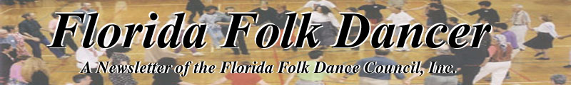
April 2005

Special Mention: Starting next month, the newsletter will only be mailed / emailed to those who have renewed their membership for 2005-2006. If you haven’t renewed already, it’s only $15 and you can mail a check to Pat Henderson (address here).

PRESIDENT'S COLUMN
by Terry Abrahams <terry.abrahams@verizon.net>
Boker Tov (Hebrew for Good morning)!
I speak in Hebrew because I just returned from Orlando, where Debbie Meiten ran her usual very fine Israeli Dance workshop, her 18th believe it or not, with ISRAEL YAKOVEE. What a treat! He is still extremely good looking (I know, what does that have to do with dancing...), an excellent teacher, taught with such humor, and of course, some of his really really good dances. I was happy to finally learn the Yemenite Rap, which has been around (I think) since 2002, and I kept missing any teaches of it. There were more attending on Saturday night than ever before - it was crowded - I was glad a few didn't show on Sunday - it's so much easier to learn when you aren't crowded in the circle. And yet, we love seeing scads of people at these things. Lots of out-ot-staters - Debbie has a good reputation. And as per usual - I love to see all my friends. BTW, the Sunday dinner was Excellent! I assume many of you will travel to either Melbourne or Gainesville (or both) for Dany Benshalom in two weeks. It's not often we have a chance to have good teachers right in our area - even though the timing is a little off. We truly have abounded, thanks to John's birthday, the Greek scene, and now the Israeli stuff.
Don'tcha just love it?
Did you enjoy the return of Mark Your Calendar in the last issue? I think it's the most important part of each newsletter (aside from my bon mots). Please make sure if you know of a coming event that you send it to Dan. We can be all inclusive - well not ALL, but all kinds of dance, perhaps music events, performances - if you are interested in, we might be too.
Disappointing news: John Lulius (Greek teacher in Tarpon Springs) is not able to do camp next year. I had mentioned him at the meeting and you all were excited about having him. Sorry! So I'm starting from scratch.
So, no one said this column has to be long. So it's not. If you're not using your feet, you're wasting your time!
------------------------------

REFLECTIONS ON DANCE
by Dan Lampert, Editor

This month, I offer some thoughtful words on dance. A jazz dancer and choreographer in Orlando, Dario Moore, recently wrote an article with this quote: “Dance is movement that occurs during a specific time (most commonly marked by sound) in a given space.” I was struck by its simplicity and the way in which it expressed the concept of dance. So, I looked around on the Internet and found the following.

Rudolf Laban (1879-1958), a notable European dancer and dance theorist, was fascinated with the relationship between the moving human form and the space which surrounds it. His biggest contribution to dance was his 1928 publication of “Kinetographie Laban”, a dance notation system that came to be called “Labanotation” and is still used as one of the primary movement notation systems in dance.

You can read about this notation system here: http://www.indopedia.org/Labanotation.html
There's also a web page on Laban movement analysis: http://www.indopedia.org/Laban_Movement_Analysis.html

Enjoy! I hope to have something “different” next month as well!
------------------------------

SPRING FLING
Saturday 30 April 2005
11 am – 11 pm
The Port Orange Folk Dance Club will hold its annual Spring Fling from 11 am to 11 pm on Saturday 30 April 2005 at the Port Orange Adult Activity Center, 4790 South Ridgewood Avenue (US-1) Port Orange (South of Daytona Beach). Turn East off I-95 at Old Exit 85 (The Port Orange Exit) onto Dunlawton Ave., Turn right onto Ridgewood Ave (US-1) just before the bridge. The center will be about six blocks south of Dunlawton Ave. on the right. Corner of White Street. Parking behind the building. Sorry – no wood floor. Air conditioned building.
Contact: Julius Horvath, Phone: 386-252-5738, email: julhorvath@aol.com, website: www.folkdance.org
------------------------------

FROM TURKEY AND HAWAII
by Raluca Ioana Rosca
<rarosca@ufl.edu>

These pictures were taken at the March 11 workshop called 'And the Goddess danced'.

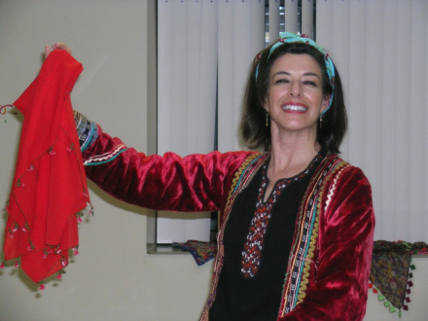
Margaret Tolbert in a Turkish costume
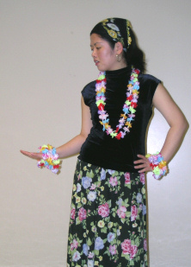
Yang Mu performing the Hawaiian dance 'The little grass shack'

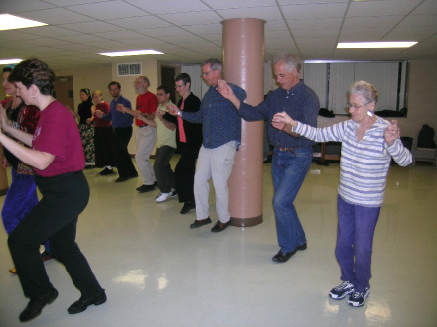
everybody lining up behind Margaret and me to do 'Neda Voda Nalivala'.
------------------------------
MARK YOUR CALENDAR
April 30, Spring Fling, 11am-11pm. Port Orange Adult Activities Center, 4790 South Ridgewood Ave., Port Orange.
May 14-24, Norway Tour with Lee Otterholt and Jim Gold. www.jimgold.com
June 10-19, Dance on the Water Croatia /Adriatic Sea Cruise. www.folkdanceonthewater.org
July 2-9, Norwegian and Swedish Music and Dance at Buffalo Gap Camp.
www.nordicfiddlesandfeet.org
July 4-13, French Canada with Yves Moreau and Jim Gold. www.jimgold.com
August 1-13, Bulgaria – Koprivshtitsa Folk Festival. www.jimgold.com
August 13-September 5, Mainewoods Dance Camp.
September 9-12, Israeli Dance Camp, Dany Ben Shalom, Ruthy Slann
------------------------------

ENGLISH COUNTRY DANCING
in St. Cloud in May 2005
by Catie Condran Geist

The Central Florida English Dancers present The Mayfair Ball on May 14th and 15th, 2005, at the Saint Cloud Senior Center in Saint Cloud, Florida (from highway 192, drive south on Budinger Street, then drive west on 17th Street).
Afternoon English Country Dance workshops on Saturday May 14th with music by Spur of the Moment (John Daly, Sheila Cootes, Bill Possi, Val Vonheeder, and Jean Murray) and teaching by Catie Condran Geist, Colette Moore, and Pam Russo from 12:30 until 4:30PM.
The Mayfair Ball will be held from 7:00 until 10:30PM, with music by Full Circle (Veronica Lane, Ben Bolker, Ted Lane, and Sandee Rose Arozqueta) and calling by Diane DePuydt, Charlie Dyer, and George and Onie Senyk.
There will be brunch and more dancing on Sunday, May 15th, from 10:00AM until 2:00PM with all of the Florida callers participating and the music will be provided by Spur of the Moment.
The cost for this lovely weekend of dancing is $20 if sent by April 15, $25 after that date. Make checks out to Curtis Stulting and mail them to:
9950 Lake Elmhurst Lane #114
Oviedo, FL 32765

For more information, call 407-923-3559 or look at the Full Circle website
http://home.earthlink.net/~full_circle_band/ where you will find information about motels.
I hope to see you all on the dance floor! (How many of you noticed that five FFDC members are listed as either callers or musicians?)
------------------------------

GRAPEVINE INT’L FOLK DANCERS SARASOTA
by Marie Millett, gvduurn@earthlink.net

Although this scribe has been negligent in reporting, the Grapeviners have been dancing up a storm every Wednesday night. Due to Ann Kessler's busy schedule she has made her way to Sarasota only the first two Wednesdays of the month. All is not lost because we have Nancy Wilusz and Andi Kapplin to teach and lead the other two Wednesdays.
We have missed Ursula Tison this last month and hope her health will improve soon.
Great visitors have come our way---Don and Phyllis from Chicago, Ron and Kathy who dance in Wisconsin but actually live in Illinois and Jim and Sara from Georgia. We look forward to their return.
------------------------------

PICTURES FROM GAINESVILLE
- Raluca Ioana Rosca

Here are some pictures from the visit of Bruce Sagan in Gainesville, taken at the party at Julieta's house. John, Linda and Jack can be seen dancing

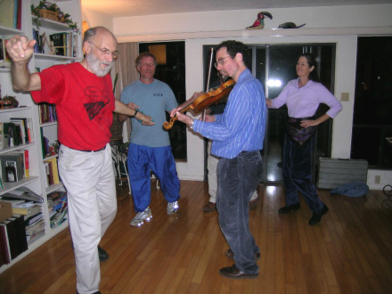.

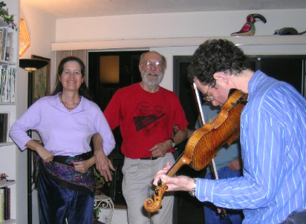
------------------------------

TAMPA TUNES
by Terry Abrahams <terry.abrahams@verizon.net>
It's hard to believe you have to read two columns by me. But I seem to be the one that sends stuff from Tampa, so....
I did my fencing in Denver. I have expanded to all three weapons now, and in spite of knowing nothing about epee (the answer in the crossword puzzles), I came in 15th out of 49! One of my more exciting moments. I did o.k. in the others, my goal being to gather points in order to make the US team for Labor Day World Championships to be held in Tampa and that mission was accomplished. One more biggie tournament in Sacramento and that phase will be finished. I've been to a number of Florida tournaments, fencing so-so (I have some major flaws that I can't get rid of), and have a good time in spite of my faults. Saturday I fenced from 9 to 6 before going on to the workshop in Maitland. And I never lose any weight - go figure. I had looked up the dancing in and around Denver, but the one time I was truly free (and not shmoozing with other fencers) there was 4" of snow, and I was afraid to drive to Fort Collins.
Our little tiny group keeps trying. Judith, Ernesto, Kevin and I did a performance at SPIFFS in Maria (the saleslady from camp) Kaloy's Bulgarian booth. No one was there to watch, but we had fun rehearsing and got in free, and got free food and got to dance too. What more can you ask? I was supposed to teach at a middle school, but the event got cancelled. The Israeli group is doing a demo this week at a grade school. Andy is very busy with his swing dancing, helping organize events, attending workshops, dancing many times a week. Bill, who still Israeli dances but has dropped out of our International group (years ago), still dashing around winning Bridge tournaments and going to Country Western and other ballroom dances. He does quite a lot of out-of-town workshops. Judith had a wonderful time at a Scan workshop in Denver (a week before my trip). We all still hit the contra scene, Andi still goes to Sarasota - with or without Ursula, who is still working on making her body better. She is helping teach when Ann isn't there. Has cards, will travel! She's due to leave for Vancouver next month. Sob! Our Israeli group really suffers when she is gone, but she doesn't care - she just leaves us alone to fend for ourselves. Well, she leaves her cards. We've had some new people coming, but they aren't ensconced enough to be regulars - but we're hoping! And I'm hoping you haven't gotten tired of my monthly comments. See you at Spring Fling!
------------------------------

RENEW OR BECOME A MEMBER OF THE FLORIDA FOLK DANCE COUNCIL, INC.
Dues for membership are $15 a year single, and $20 for family and are renewable by March 1. Please send check made payable to FFDC to the treasurer:
Pat Henderson
9859 Berry Dease Rd
Orlando, FL 32825
In addition, please state whether you want the newsletter by email or regular mail.
------------------------------

DANCING IN SEATTLE

Last Friday night (March 19) I was dancing with the Seattle folkdance group. How did I found them? I did a web search in the (not always updated but still the best around) National directory(www.folkdancing.org), find the phone numbers for the local organizers, once in Seattle I've called Jana Rickel to confirm the meeting time and place and ...there I went: 7220 Woodlawn Ave NE, Seattle. One can join every Friday from 8 30 for the dance($5) or come at 7 30 for the class ($7, includes dance afterwards). In terms of 'good floor' and 'nice feeling to it', the Veterans of Foreign War Hall has plenty of places for improvement: the floor was plastic on cement, and the large dance space was bordered by lockers, mattresses, 'Attention, wet floor' signs and a general work-in-progress atmosphere. However, the group was surely making the best from what they had: lamps with colored bulbs were clipped to the windows, and the 30+ people in there were filling in the place with dance and conversations (the front stage of the hall was used to deposit bags and to sit people in between dances). The payment was on the honor system, with a recycled cookie jar in which one can put the money and a sign posted on the table by the door.
All their music was on mini-disks, grouped by countries. They didn't have a music catalog per se, just a Rolodex-like system, with each dance name written in big upper case characters on a pieces of cardboard (approximately 4 by 12 inches) and a wood-board with pockets in which the name cards were inserted. There was no official teaching from 8 30 on, just request, and anyone who wanted a dance would go up front, look for the name card, and put it on the board. The card with the name of the dance 'playing now' was slid out from the board a few inches, so it was no confusion on what is playing. Nobody came to me to say 'hey, I haven't seen you around, is it your first time?' but they've been friendly when approached, and at the end invited me to come back . I knew and danced about 1/3 of their repertory--early in the night they preferred low impact dances, while toward 11 I've witnessed some pretty impressive sborinkas (several members of the group were in an Yves Moreau workshop a little ago, so the repertory was leaning toward Bulgarian that night).
I've talked a little more to one of the organizers (Liliana) and she was telling me that the group was ready to close about 1 year ago, because the attendance was dropping and they weren't able to cover the 180/night rent for the hall. The got out of the crisis by aggressively advertising in the 'Cultural Scene' supplements of the town newspaper, calling former members and, more interesting, by reforming the teaching segment! The present system, that seems to work fine, is to have 6 weeks long session covering 4-6 dances. All that is taught during such a cycle are the predefined 4-6 dance, with one more complicated dance being worked for all 6 weeks, while the other dances are taught once and then reviewed periodically during the cycle. I didn't get there in time to see the teaching, but I can testify that when dances from the teaching part were played later during the night, most everyone got up to dance them. I thought that the cycle of sessions was a great idea and it might be something we'll want to experiment with in Gainesville. I took pictures with my disposable camera, and if they came out good, I'll make sure to send them to the
FFDC newsletter!
See you all dancing (in Florida) -Raluca
------------------------------

DANCING DOWN UNDER
An email by Martin Williams of the Perth International Folk Dance Group in Australia
Martin.Williams@westernpower.com.au

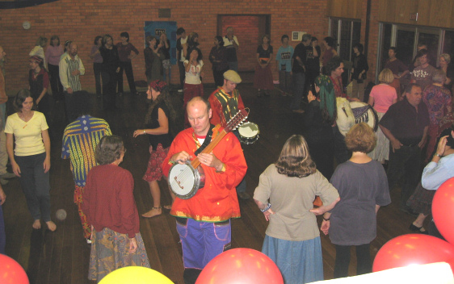

Saw your email on Florida Folk Dancer site… Liked you digital pictures. I've attached some taken at our special night this Monday with the Gypsy Group Xenos. We had over 70 dancers. Folk dance is alive and well!

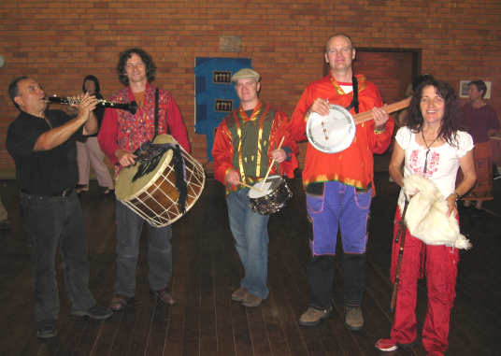

We live in Perth in a very isolated corner of Western Australia (WA). Our nearest big city neighbor is in Singapore, so it's not even in the same country and is a 4-hour flight! WA is about 4-times the size of Texas, and about 70% the size of the USA, with about one two-hundredth of the population!!
Good to hear from you. -- Martin
------------------------------

TAP DANCING AT FAIRWAYS
by Joy <hrndj4@aol.com>

"DANCING DOWN BROADWAY" The dance show, presented by Pat Bryant and the "Class Act Dancers” on March 18-20, played to a full house at each performance. If you had a chance to see the show, you realized the time and effort it took to make it memorable for all that attended..The International Dancers added a touch of traditional dancing to the show. I truly love it..also Phillis Dammer was in our group too..she is in the Orlando group..our show lasted 3 days (Friday evening, Saturday evening, and Sunday afternoon). Pat & Bobby / Palmira & Manual were both there Sunday. Thanks to everyone who helped put the program together and make it successful and special thanks to Pat Bryant for her endless patience and dedication.

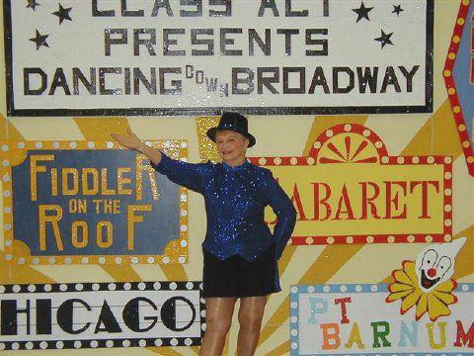
Joy tap dancing

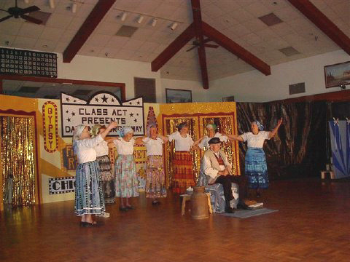
Juanita and daughter and others doing Fiddler on the Roof
------------------------------

FFD Camp
Lost and Found Update

Carol McGinn has written to me that her Mom's scarf, which was thought to be lost at camp, was found on April 10 -- rolled up in a pair of shorts. She explained to me that she has not worn these shorts since camp -- or even taken a look at them -- because she’s in Albuquerque and it's snowing there right now. And she thanks all who went looking for the elusive scarf.

FLORIDA FOLK DANCER

Florida Folk Dancer is a monthly publication of the Florida Folk Dance Council, Inc., a non-profit corporation whose purpose is to further knowledge, performance, and recreational enjoyment of International Folk Dance.

2005 FFDC OFFICERS:

President: Terry Abrahams
813-324-1231
terry.abrahams@verizon.net

VP: John Daley
321-951-9623
jbdaley@compuserve.com

Treasurer: Pat Henderson
407-275-6247
henderp@bellsouth.net

-

Return Address
FFDC Newsletter Editor
Post Office Box 151719
Altamonte Springs, FL 32715-1719
USA

FIRST CLASS

Secretary: Jean Murray
321-952-7025
mmurray9496@cfl.rr.com

Editor / Dan Lampert
Historian: PO Box 151719
Altamonte Spgs., FL 32715
dan@webuniv.com

Send all submissions to the Editor during the last week of the month, to be published the first week of the next month.
Copyright: articles in the Florida Folk Dancer are copyright by the Florida Folk Dance Council, Inc., or by their individual authors.
Subscriptions are $15 per year and include membership in the Florida Folk Dance Council. The membership year runs from one Annual Camp (usually February) to the next. Members can receive the newsletter electronically if desired.
For more info: www.folkdance.org

