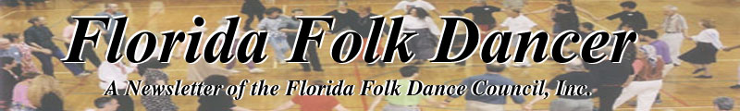
May-June 2005

PREZ SEZ
by Terry Abrahams <terry.abrahams@verizon.net>
Hi everyone! A few thoughts on my mind. First, I note that Dan is sending interesting activities to us one at a time. Which is fine for us email folks. But, I’m worried about those who receive their newsletters via snail mail. I’m hoping that even though you have chosen to receive it by regular mail, that you are receiving these bulletins on your email addresses. If you are not, you’re missing possible great activities, and you want to tell Dan to get you on that list. The other thing is that for those who are sending these things to Dan for print, if you know about them way ahead of time - please get them to him to be put into the newsletter. I realize the newsletter has been peripatetic (like that word?) in terms of continuity, but we’re hoping Dan gets onto a schedule whereby you’ll know your newsletter is coming every month – at the first of the month.
Second, I want to talk about the Spring Fling. For those of us who attended, we had a great time. But therein lays the problem. As the years go by, fewer and fewer of us attend this wonderful party that Julius throws every year. In case you are not aware, Julius does this entirely by himself. He has no group, and therefore no help, and thereby pays for the hall, all the food, prepares the food, sets up the room, provides the music – have I missed anything? He and I are wondering if it’s worth all of this trouble if so few people attend. (Plus he may not get the hall for next year – so should he hunt for a new one?). SO! Why aren’t we attending? Here are the possibilities. I do know that this year, one group was performing the next day, and didn’t want to be too exhausted to do well. But where was Sarasota (1 person attended), where was G’ville? There were at most 40 people there. We run about 80 at camp. Is this about all we should expect? Or….is the Spring Fling too close to camp? (In the past one of the reasons to have it was to review camp dances, but maybe it’s just too soon to get together again). If we had it closer to summer, would you come? Do we not need 3 activities wherein we all join together? We used to have a gang performance night in a different city once a year, and we used to many of us perform at the Florida Folk Fest, which isn’t happening these past few years. In my mind, 3x a year is not too much to see all of you and dance as a big group. It’s free, so that’s not your reason. I’d like to hear from you regarding this. Please talk to your people, one of you send in some info to the next newsletter. Either through your club’s column or a special letter, which Dan will print. We have plenty of time to decide on next year, but let’s think about it ahead of time.
And thinking of ahead of time. Hope to see some of you at the Florida Folk Festival next week (this won’t be ahead of time when you receive this newsletter) and I’m hoping to look at a camp with a wood floor near G’ville on my way up. Pat H discovered it. If it’s available and great, we could possibly change the date back to Presidents weekend. More next month on that. OK – over and out.

------------------------------

FLORIDA FOLK FESTIVAL
by Dan Lampert, Editor

I sent an email about this, but it bears repeating… The Florida Folk Festival is this weekend, May 27-29, 2005. It’s a very large festival and it offers: music, crafts, dance, food, history, exhibits, and banjo/fiddle contests. Dancing is well represented here, and Terry Abrahams will be teaching Israeli dances with the Klaysmer band on Saturday night from 7-9 PM.
Location: the location is White Springs, which is north of Gainesville on I-75, where I-75 crosses I-10. If you are in Orlando, make a car-pool with your friends.
Price: $15 a day per person or $35 for the weekend. If you register online, you’ll save $5.
Their web site is comprehensive and beautiful. For complete information, click here: www.floridafolkfestival.com

------------------------------

ORLANDO INT’L FOLK DANCE CLUB
By: Pat Henderson

Yes, we are still dancing in Orlando although we came close to selling the farm recently! Of course, the group is happy that Bobby and I are still here. In fact, the group threw a wine and cheese party on April 27 just because it had been awhile since we had a party. It was also Joan and Wally Washington's last night with us before their hiatus to Michigan for the summer. A smaller number than usual from our group attended the Spring Fling in Port Orange on April 30. Thanks again to Julius for all the work that he did in providing a very special day of dancing. The event with all the trimmings is his gift to the Florida folk dance community. It was great to have a day of request dancing. By the time that you read this, Altyn Kuanishbaeva will be headed back to Kazakhstan. Many of you enjoyed meeting her and dancing with her at camp. Her belly dance will be one of the most memorable moments from this year's camp. We wish her all the best as she returns with a U.S. high school diploma. One phenomenal coincidence is that she was placed in the home of Beck Hutchinson who dances in Ann Robinson's Middle Eastern group. Neither of them specified dance on their exchange student paper work! Speaking of Ann, she and her husband, Danny, are leading a trip to Branson, Missouri, from September 26 to October 1. The cost including airfare from Orlando, lodging, breakfast, dinner, buses, and 10 shows for about $1,100. If you are interested in joining the group, contact her at: 407-671-7748.
Bobby and I attended the Mayfair Ball in St. Cloud on May 14. We enjoyed the English dance event and we heard that 65 people attended. It is always great to dance to live music and Full Circle provided excellent tunes. Two Cousins was chosen as the first dance of the ball. George Fogg would be so proud!
Traveling since the last newsletter article includes: Lucy Birkemeier to Chicago to help out after her son's appendectomy, Eva Gaber to California for Passover and Juanita Schockey to West Virginia for the last high school graduation of a grandchild. Bobby and I plan to attend the Florida Folk Festival in White Springs over Memorial Day weekend.
Remember that our group dances every Wednesday through June. We take July and August off.
Special event night: Wednesday, June 1, 7:30pm.--Join us for a joint 75th birthday party for Juanita and a 9th anniversary celebration for Joe and Lucy Birkemeier. June 1 is actually the date for both of them. Juanita is planning to bring most of the birthday goodies herself.

------------------------------

A POEM FROM A DANCER AT THE SNOWBALL
by Susan Levasseur, written December 5, 2004

White lights,
a wood floor,
stars in the ceiling.

Musicians mellow as soft air
and a story stage.
A caller; rhythmic as a drum.
Smooth cement stairs
and a pure white door.

In the glossy, spiked windows:
dancers spiraling phantom swirls;
larger than life.

I open the door.

A whole new world…
and I forget myself.

My petty, parapet will
dissolves into walls,
into dance driven
larger than life.

Heroes and heroines.

Embraces of shared lives.
Mixed blood, ruddy cheeks,
pounding hearts – and we dance!

We play heroes and heroines—
music, our flashing sword.
Our skirts – great red capes
and our men with warm sweaters;
and our men dance!

Larger than life
and better.
------------------------------
MARK YOUR CALENDAR
Saturday, June 4, The Celtic dance invasion: Breton and Irish Set dances
WHERE: 308 W University Ave (the NEW GDMA building!)
WHEN: Saturday, June 4, 2- 5 pm
$?: Free to UF students; $5 for all others; no partner required; people
of all ages and dance levels welcome
Q? Contact Stefan Craciun /craciuns@ufl.edu/ 352-870-0526
WHAT: Doriane Rencker and Yutaka Usui
(http://www.geocities.com/wildsets/) presenting:
Breton dances- what the Celtic population of Brittany, France was doing
in Roman Empire times and is still doing &
Irish music was MADE FOR SETDANCING not Riverdance - Men, keep your
shirts on!! In Irish pubs today, all the rage is the incredibly fun Setdancing !!
June 10-19, Dance on the Water Croatia /Adriatic Sea Cruise. www.folkdanceonthewater.org
July 2-9, Norwegian and Swedish Music and Dance at Buffalo Gap Camp.
www.nordicfiddlesandfeet.org
July 4-13, French Canada with Yves Moreau and Jim Gold. www.jimgold.com
August 1-13, Bulgaria – Koprivshtitsa Folk Festival. www.jimgold.com
August 13-September 5, Mainewoods Dance Camp.
September 9-12, Israeli Dance Camp, Dany Ben Shalom, Ruthy Slann
------------------------------

NEWS FROM GAINESVILLE
by Raluca <rarosca@ufl.edu>

Things to do in Gainesville (see for the whole list: http://www.satellitemag.com/?q=issue/2005/may/topten )

We have to thank Tanya Beatty for this great description:
"UF International Folkdance Club meetings on Friday nights are always fun. You get to do something fun, learn about different cultures, and actually be doing something meaningful on a Friday night. The people are some of the nicest, down to earth people you will meet and make you feel like family. And if you like meeting people from different cultures, you will find some there as well. "
in other news…
Thanks to June's PR efforts we've seen the first workshop announced on Marilyn's 'Dance News' and in other 10 locations.
She would be out of town for the second workshop, so let me know if you'd like to do the PR for the second workshop. Designer for the Alligator's ads most needed.

TAMPA – HMMM, no cleverness today - JUST TAMPA by Terry Abrahams <terry.abrahams@verizon.net>

Andi sent a quick note to say “we arrived safely yesterday and I'm on a dinner break from the Israeli workshop. Already learned 4 FABULOUS dances. “ (She has a workshop there immediately upon arrival – nice way to start he summer), while our Israeli group limped along without her Tuesday.
I finally decided to expand my dancing world and went to the Mayfair English Country Ball. I got to Orlando early, learned how to “do” my computer, which Bobby has generously loaded with all of his dances from his computer – we tried it Friday night and Andy approved and we will be able to stop lugging our tapes around. Believe it or not, we thought of a few dances Bobby didn’t have. I didn’t think that was possible! Got to the workshop where John, Jean and I played in one of the rooms. while Val and someone else played in the other room. (I LOVE to play – too bad I don’t practice and get better) There were very nice snacks, so they would dance 1/2 hour, small break, etc. Then a two hour break for dinner and a bunch of us went to a seafood restaurant that was excellent. On back, changed to our "costumes" and there was a really good band for the evening, so we had a good time. Not as many men as we would like (quel surprise) but – what the hey! Next day instead of going back to the workshop, I joined the Orlando Israeli gang for a performance at a Sunday School, and after they figured out how to get the electricity working (!), we did 3 dances and then taught the kids a couple. It was good to see the Orlando group again. I got home in time to hear the symphony play a Mancini night. What a nice weekend. I’m also doing lots of theater stuff, have decided to contribute time to the American Cancer Society, went down to Sanibel to see my sis – so I keep busy!
Our Jen (Israeli) graduated last week, she will leave us at the end of the month. Sad for us – happy for her – she’ll be working at Disney – so will join the Israeli group there. Ursula is in the Ukraine, Ken leaves for camp soon. Summer is tough for us! But Bobby Ward has been coming a little to Friday night, Ken has too. So that has helped. We also Russell (from Spring Fling) come one night, which was great! Wasn’t he a nice addition to the Fling…
I think this issue is to be in a two-month at a time newsletter – so I can’t figure out whether I will have been in Bulgaria before the next one or not. I’m traveling with Jim Gold (who is with some of our FFDC people in Norway, with Lee – as we speak), and I think there’s over 30 of us now. You can still join if you want! See ya! Terry
------------------------------

Pictures from FFD Camp
Ocala, Florida, 2-27-2005

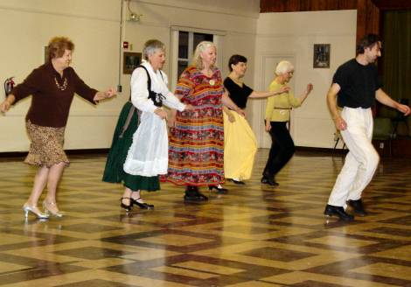

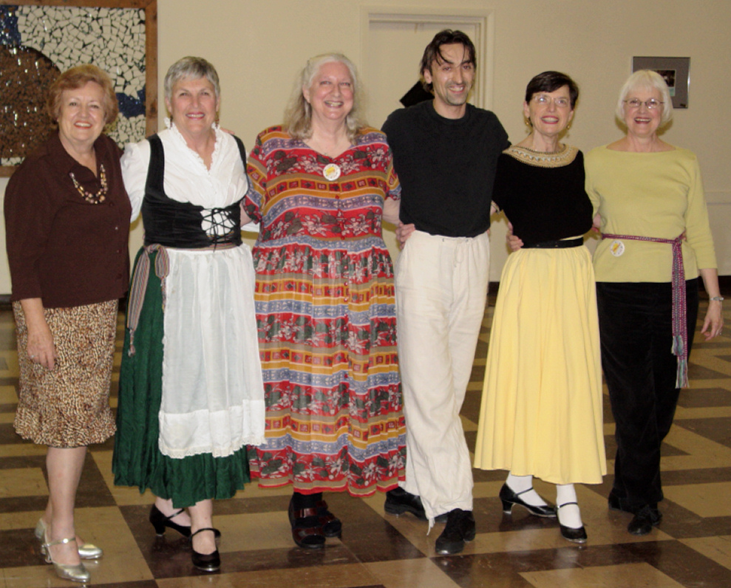
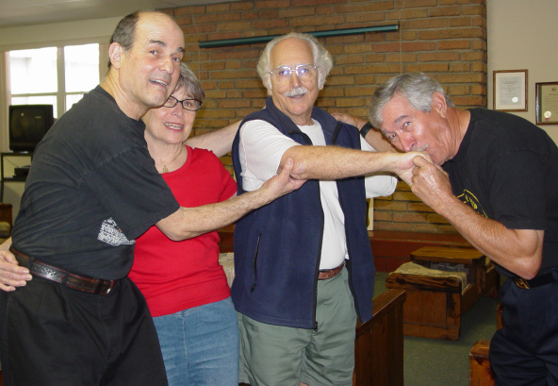

Pictures from OIFDC Meeting
at Bobby and Pat's Place
Orlando, Florida, 3-30-2005

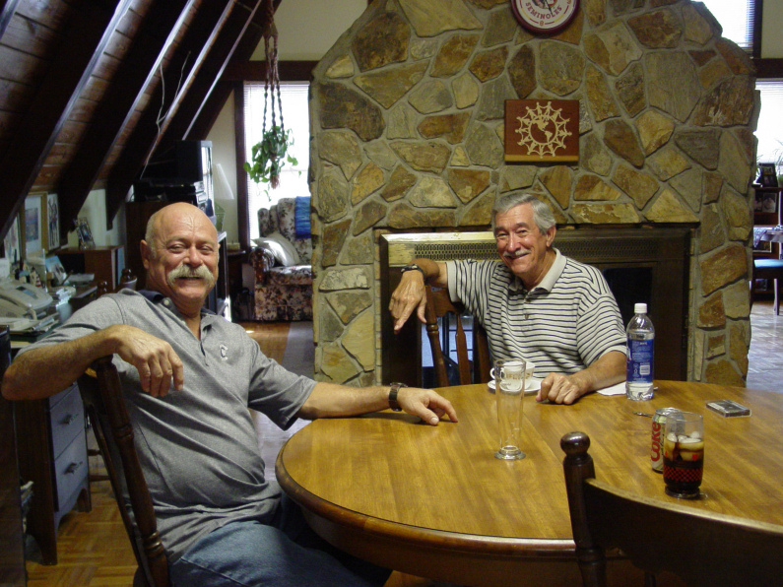

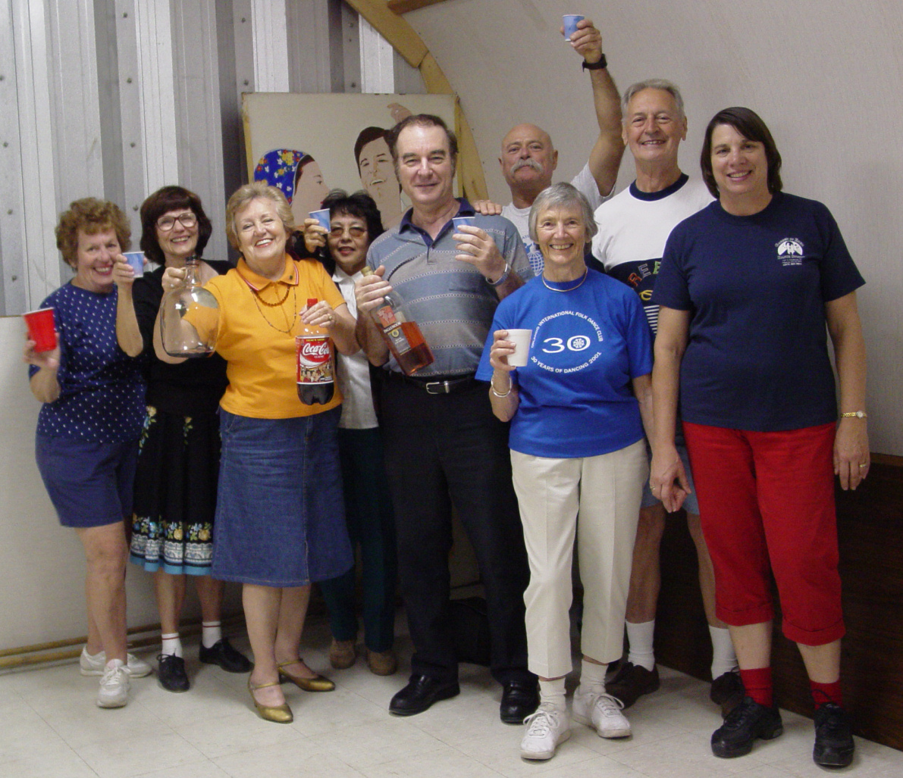

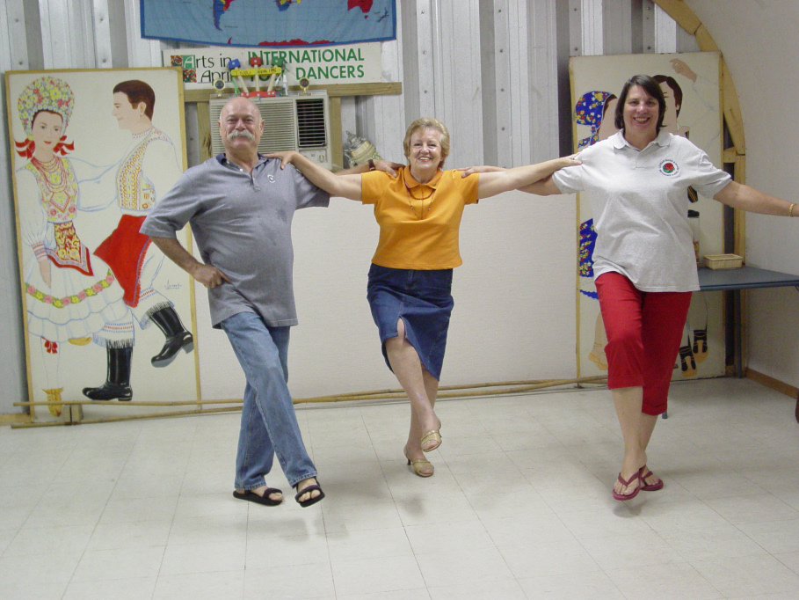

All pictures sent in by Ann Kessler

FLORIDA FOLK DANCER

Florida Folk Dancer is a monthly publication of the Florida Folk Dance Council, Inc., a non-profit corporation whose purpose is to further knowledge, performance, and recreational enjoyment of International Folk Dance.

2005 FFDC OFFICERS:

President: Terry Abrahams
813-324-1231
terry.abrahams@verizon.net

VP: John Daly
321-951-9623
jbdaly@compuserve.com

Treasurer: Pat Henderson
407-275-6247
henderp@bellsouth.net

-

Return Address
FFDC Newsletter Editor
Post Office Box 151719
Altamonte Springs, FL 32715-1719
USA

FIRST CLASS

Secretary: Jean Murray
321-952-7025
mmurray9496@cfl.rr.com

Editor / Dan Lampert
Historian: PO Box 151719
Altamonte Spgs., FL 32715
dan@webuniv.com

Send all submissions to the Editor during the last week of the month, to be published the first week of the next month.
Copyright: articles in the Florida Folk Dancer are copyright by the Florida Folk Dance Council, Inc., or by their individual authors.
Subscriptions are $15 per year and include membership in the Florida Folk Dance Council. The membership year runs from one Annual Camp (usually February) to the next. Members can receive the newsletter electronically if desired.
For more info: www.folkdance.org

BEGINNING BANK BALANCE: January 1, 2004: |  |  |  |  | 9271.32
NEWSLETTER | 869.78
FL DEPT STATE | 122.50
OFFICE | 189.27
WEB ADDRESSES | 140.00
CAMP 2004
SYLLABUS | 465.29
PETTY CASH | 250.00
INSTRUCTORS | 1,814.70
VENDOR | 100.00
SNACKS | 95.67
FACILITIES | 8,624.50
T-SHIRTS/BUTTONS | 363.33
REFUNDS | 700.00
VIDEOS | 363.99
RETURNED CHECK | 215.00
CAMP 2004 TOTAL | 12,992.48
DEPOSITS | 9,957.82
DUES | 280.00
CAMP 2005
SYLLABUS | 546.24
PETTY CASH | 200.00
INSTRUCTORS | 2,035.70
GIFTS FOR OFFICERS | 30.00
SNACKS | 93.60
FACILITIES | 8,671.15
T-SHIRTS/BUTTONS | 402.41
REFUNDS | 706.00
VIDEOS | 418.95
REG. FORMS | 143.08
CONTEST WINNERS | 47.00
CAMP 2005 TOTAL | 13,294.13
DEPOSITS | 13,758.00
CAMP 2006
DEPOSIT | 175.00
TOTAL CREDITS: | 33,267.14 |  |  | TOTAL DEBITS: |  |  |  | 27,783.16
ENDING BANK BALANCE APRIL 30, 2005: |  |  |  |  |  | 5,483.98
TOTAL INCOME | 23,995.82

Since the last financial statement for FFDC was for calendar year 2003, I have prepared three reports. One takes
the time period January 2004 through April 30 2005. The other two are for each camp. I believe that the
treasurer should start April 1 and an amendment to the bylaws to this effect has been suggested by Ann Kessler.
It is hard to separate camp income from membership so most membership dues are added to camp deposits. Some
amounts have changed from the balance sheet report since records from November and December 2003 plus
April 2005 have been added to complete the camp report.
 |  |  | Respectfully submitted, Pat Henderson, Treasurer, FFDC
 |  |  | P
CAMP 2004
SYLLABUS |  | 465.29
PETTY CASH |  | 250.00
INSTRUCTORS |  | 1,814.70
VENDOR |  | 100.00
SNACKS |  | 95.67
FACILITIES |  | 8,624.50
T-SHIRTS/BUTTONS |  | 363.33
REFUNDS |  | 700.00
VIDEOS |  | 363.99
RETURNED CHECK |  | 215.00
TOTAL EXPENSES |  | 12,992.48
CAMP 2004
TOTAL INCOME |  | 12,662.82
PROFIT/LOSS 2004 |  | -329.66
CAMP 2005
SYLLABUS |  | 546.24
PETTY CASH |  | 200.00
INSTRUCTORS |  | 2,035.70
GIFTS FOR OFFICERS |  | 30.00
SNACKS |  | 93.60
FACILITIES |  | 8,671.15
T-SHIRTS/BUTTONS |  | 402.41
REFUNDS |  | 706
VIDEOS |  | 418.95
REG. FORMS |  | 143.08
CONTEST WINNERS |  | 47
TOTAL EXPENSES |  | 13,294.13
CAMP 2005
TOTAL INCOME |  | 13,758
PROFIT/LOSS 2005 |  | +463.87

