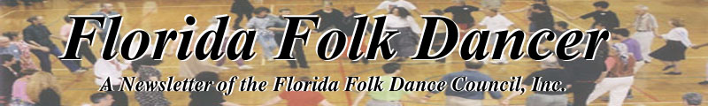
July/August 2005

PREZ SEZ
by Terry Abrahams <terry.abrahams@verizon.net>
Hey y'all! Hope you're having a good dancing summer - even in this heat and rain! The major news is that your board is working on the possibility of different camp - with a wood floor, the ever elusive special feature that we would love to have. So far, we've deleted three camps that we thought might have served us well when we first looked. One camp we had to have kids, one we couldn't dance (oops!), and one had columns in the dance room. We haven't completely eliminated one that has the wood floor, but no AC. The cabins are not as nice but it is cheaper. It is in Keystone Heights (north of Deland) and is available in January or February on the holiday weekends. If we changed to January, then maybe we wouldn't need the AC. I'm not excited about it, but it's out there. One thought we've had is to have all of you look around your village and see if there are any oldy moldy hotels that still have ballrooms.
This wouldn't be a camp, but would be a "community" situation and could work. Any takers on this??? We're also looking at conference centers, if you know of a good one. In the meantime, we have our usual camp locked in, so we aren't without. Just thinking .. I've been extremely involved in helping the American Cancer Society get it's Road to Recovery program back up and running and have been a bad girl about seeking instructors. I know there's time, but by the next newsletter, I hope to have news. And so I end with - You can live without dancing, but not as well.

REFLECTIONS ON DANCE
Instead of an article this month, I have a quote for you. I authored it this morning, as I was replying to some emails about swing dancing in the Orlando area.

“Dancing is healthy, fun, mysterious, inevitable.”
- Dan Lampert 7-13-2005
------------------------------

PICTURES FROM THE MAYFAIR BALL
By: Terry Abrahams on her new camera
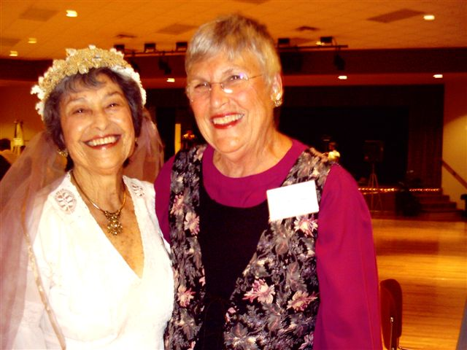
Bernice Roth and Terry Abrahams

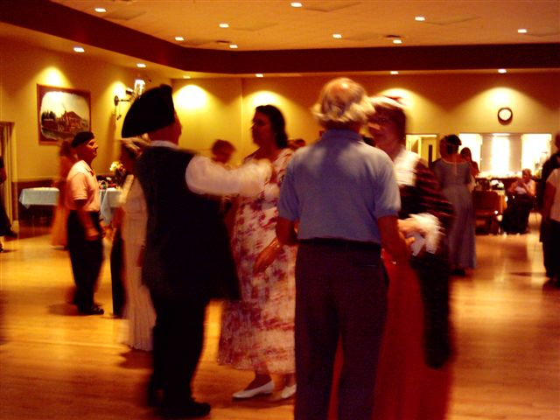

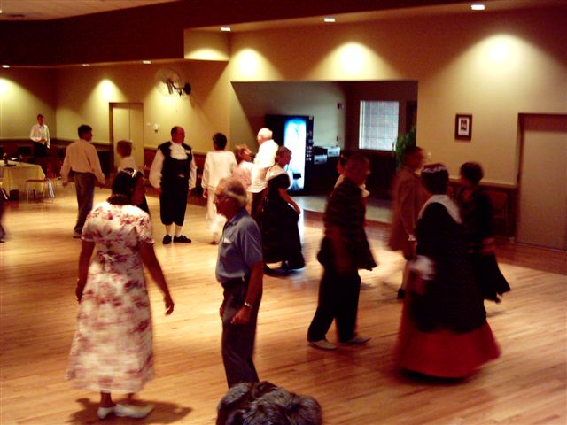

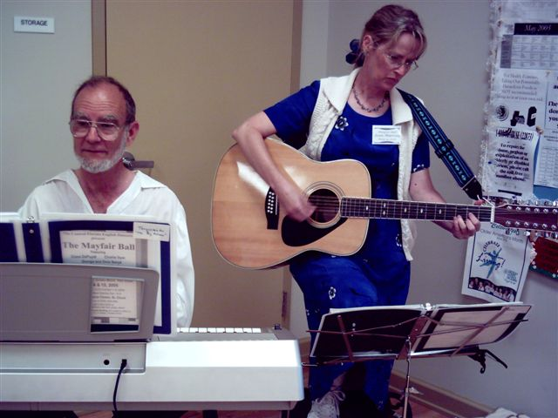
John and Jean rehearse

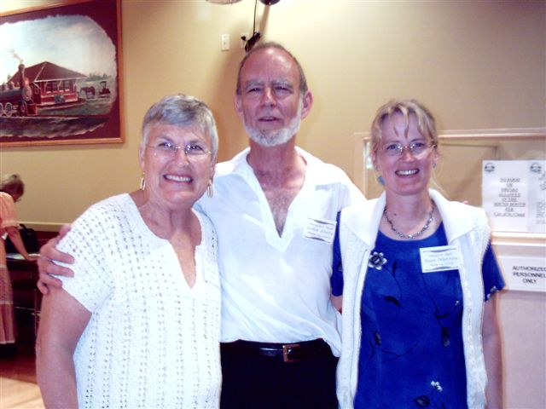
Terry, John and Jean

ORLANDO INT’L FOLK DANCE CLUB
by Pat Henderson <henderp@bellsouth.net>

Bobby and I were the only ones from our dance group who attended the Florida Folk Festival in White Springs over Memorial Day weekend. We helped Terry Abrahams lead Israeli dances to a Klaysmer band from Gainesville. We shared a campsite with the band along with Terry and Jean Murray. It was the first time that Bobby and I camped after going there for so many years and getting a motel room. It was not loud all night as I had suspected although Terry and Jean did go off to find a band to jam with when Bobby and I called
it a night.

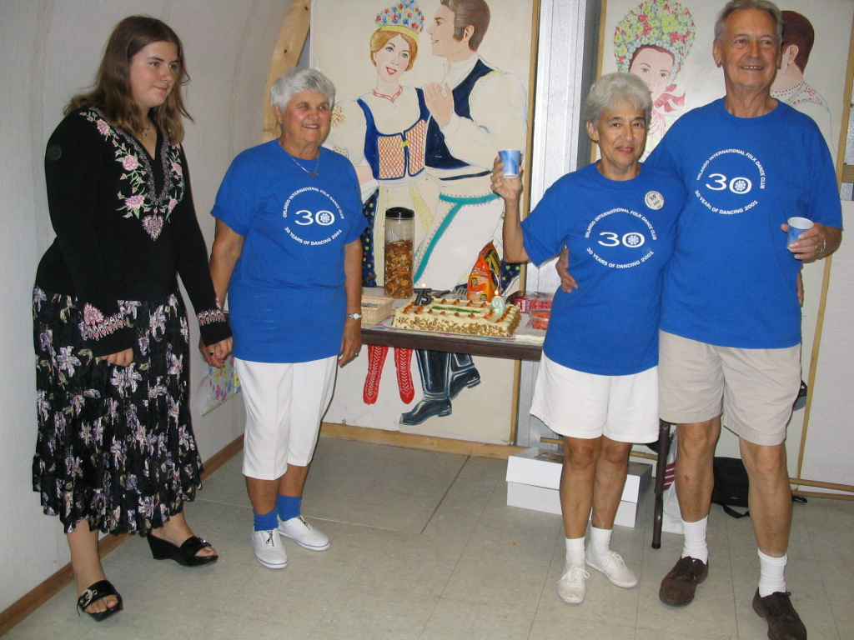
Juanita’s 75th Birthday and
Joe & Lucy’s 9th Wedding Anniversary

On Wednesday, June 1, we had a joint birthday and anniversary party. Juanita Schockey was celebrating her 75th birthday and Joe and Lucy Birkemeier were celebrating their 9th wedding anniversary on that day. Then Emilie Brozek brought one of her granddaughters who was 13 that day. Talk about a big day -- it truly was. We had about 24 attend that night. Orlando had record rainfall in June so we did not dance on 15th after we received three inches of rain that day. We did not ease into the rainy season at all this year.
Travels this month included: Ellie Hall to California to visit family and Ann Robinson to North Carolina for a two week ceramics seminar with a Turkish instructor.
For those interested in our property situation: we are temporarily off the market while we haggle with the county about splitting the 8.5 acres into three parcels. So if anyone knows anyone who wants to move to Florida, tell them to contact us especially if they are a folk dancer!

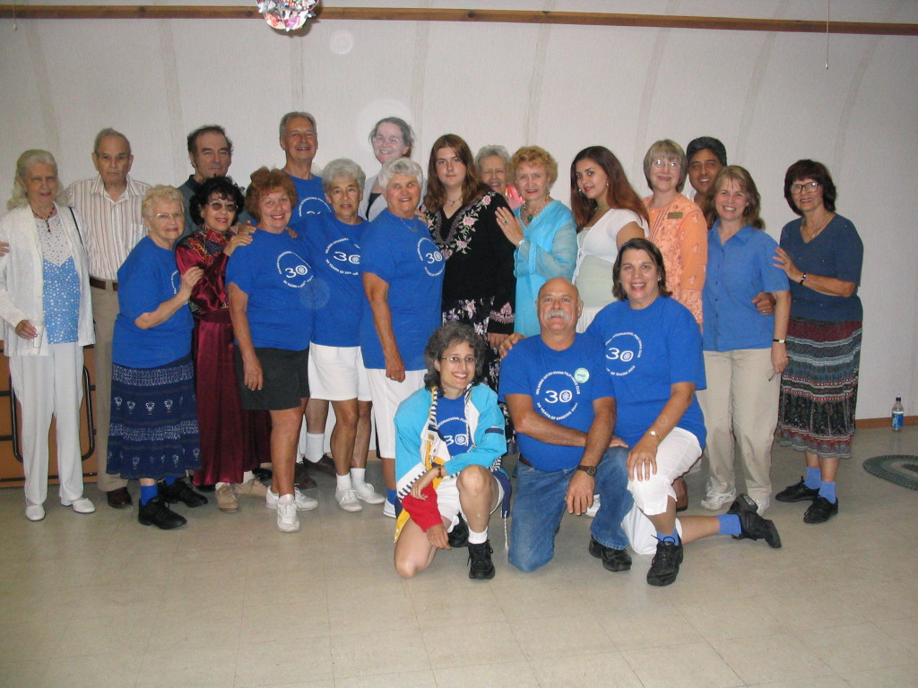 The OIFDC group picture on June 1, 2005
------------------------------

MAINEWOODS DANCE CAMP
by Dan Lampert

With events starting August 13 and concluding Sept. 6, 2005, they have an impressive schedule… with teachers we know - Lee Otterholt and George Fogg!!
See all the information online at: http://www.mainewoodsdancecamp.org
If you have questions, you can contact Kay Demos, their webmaster and coordinator. Email: kay@mainewoodsdancecamp.org
------------------------------

JUNE DANCE CHRONICLE
by Raluca <rarosca@ufl.edu>

I was out of town for 3 weeks, but from the messages on our email list and the general feel of the place, I can assure you: dancing at 308 W University Avenue, GNV is fun (and gentle on your joints as the place has nice wooden floors).
FYI , here are the dance we’ve covered since we moved in this new building (forgive our spelling). On 6/3/05 we’ve danced
1. Djanguritsa (Bulg.), by Jack Seltzer
2. Manavu (Isr.) by Jack Seltzer
3. Hasapiko (Gr.) by Margaret Tolbert
4. Latica (Bulg.) by John Ward
5. Korabushka (Rus.) by Jack Seltzer
6. Delilo (Turk.) by Margaret Tolbert
7. Posiskliute Patrioti ( ) by John Ward
8. El LLanero (Venez.) by Raluca Rosca

After an excellent first Friday, we had a good Saturday Celtic dance workshop (see details in a different message — I reiterate my recommendation of Dorianne and Yutaka for the FFDC camp.) .
On 10 June 2005:
1. Zumpa Ondo, Japan, Julieta
2. Ajd'Nalijevo, Croatia, Joyce
3. Bannielou Lambaol, France, Linda
4. Davorike Dajke, Julieta
5. Djanguritsa, Bulgaria, Jack
6. La Bastringue, Canada, Jack
7. Pasisliute Patrioti, John
8. Belasicko Oro, Macedonia, Joyce
9. Korabushka, Russia, Jack
6/17/05
1) Kortanc - Linda
2) Osmica - Joyce
3) Ma Navu (reviewed) - Jack
4) Lalica (review) - John
5) Kargouna (review) - John
6) Davorike Dajke (review)- Julieta
7) Zumpo Ondo (review) - Julieta
8) Kochari - Jack
9) Belasicko Oro (review) - Joyce
10) Delilo (review) - Margaret
11) Hasapikos (review) - Margaret

This good dancing Friday evening was followed by a fundraiser for GDMA. Jack Seltzer reports:
“By the way, was fun seeing everyone for breakfast yesterday at Applebees.....Gary really is good at flipping those pancakes......Chimo (Joaquin) also helped in the kitchen and so our coffee came out real steamy and full bodied......(now if only they both can dance as good as they can cook.....)”
Peggy collected $$$$ at the door.....Sherry helped serve the folks who were able to sit, relax and listen to the live sounds of a 3 piece band......These 2 ladies have really given the group a great boost every Friday night....[..]
Actually they've all given the group a shot in the arm and they all are getting better at faking more and more of the dances.....”
6/24/05
1. Sborinka (Bulgaria) taught by Julieta,
2. Osmica (Bulgaria) reviewed by
3. Joyce, Sepastia Bar (Armenia) taught by Joyce,
4. Sulam Yakov (Israel)taught by John,
5. Kochari (Turkey) reviewed by Jack,
6. Yolanda (Puerto Rico) taught by Julieta,
7. Kissufim (Israel) taught by Linda,
8. Tetovsko Oro (Bulgaria) taught by Margaret.

Joyce reports about this one: “For the very first time in a long while I stayed and danced the entire evening. It felt like old times. Each time I thought I would leave then music for another great dance was played.
Thanks to Jack and Max who kept things rolling with the music and programming. Over 20 people were there and all had a great time. We had some new folks again. The PR in The Gainesville Sun really has helped. Thanks for those who are doing the publicity! [..]
Tetovsko Oro was a real foot twister but Margaret has assured us that once our feet get it we can do the dance without having to think about the instructions. The range of dances - easy to more difficult, and the(as always) wonderful music were a treat.”
Once again a good dancing Friday was followed by an eventful Saturday, this time a ‘pro-dance’ garage sale hosted by Julieta (she might have wrote y’all a separate message—on short, many have helped, many are to be thanked and the action brought in $325 for GDMA and about $140 for our group).
7/1/05
1. Ekijslisko Oro - Bulgarian - Jack
2. Sborinka- Bulgarian - review - Julieta
3. Hora din Gocesti - Romanian - Linda
4. Kinneret - Israeli - Julieta
5. Vulpuista - Romamian - Margaret
6. Keciko - Turkish - Margaret
7. Baztan Dantza - Basque - Jack
8. Yolanda - P. Rico - review – Julieta

This time I was back in town after a non-dancing tour of the Pacific NW and it surely felt good to be folk dancing again. Joyce Story was visiting from Arizona, and she joined us for maybe the 10th times in 4 years. Our newest young recruit, Yong (not Yang Mu that you’ve all met, but a Korean lady with a past in performance gymnastics and a present studying in College of Health and Human Performance) was once again picking up dances amazingly quick, and she brought with her a friend that likes to dance as well. Jenneine was visiting from Naples, June was in town and dancing, her appendectomy forgotten, Radha of the Girlscouts International Thinking Day memory was there as well, together with her daughter. I should really be mentioning every one of the 20 people in audience as the night was totally electric but the prize goes to John Ward – he came to dance even if his house was burglarized earlier that evening (no apparent damage)
SO…Join us Friday night at 8 pm, year round, or send over that friend who just moved in town/ is passing by. $3 for adults, $1 for dancing children and even seating places for non-dancing members of the party ---what else can I say? Oh, yes, even with people traveling we still have ~ 20 people every week, but the place can easily accommodate 40 people or more. Come to see it and give us your vote—would it be a good place for Spring Fling 2006?
------------------------------

BELLY DANCING

An event in Gainesville 7-31-2005

Ethnic Dance Expressions - School of Belly Dance present their 3rd annual event
"Veils & Visions Revue" An afternoon of Middle Eastern and Spanish dancing
Sunday, July 31, 2005
3:00 PM - Doors open
3:30 to 5:30 PM - Show begins
Location: Indian Cultural & Education Center
1115 SW 13th Street
Gainesville (just south of UF between Archer Rd. and SW 16th Ave.)
Tickets:
Adults: $12 Advance / $15 At-door
Seniors 60+: $10 Advance /$13 At-door
Children under 10: $5
Reservations Required for At-door Tickets
Advance tickets may be purchased at
Ethnic Dance Expressions - Plaza West - 4000 Newberry Road D-2
Contact: Sallamah Chimera, Director
352-384-9200
sallamah@bellsouth.net
www.ethnicdanceexpressions.com

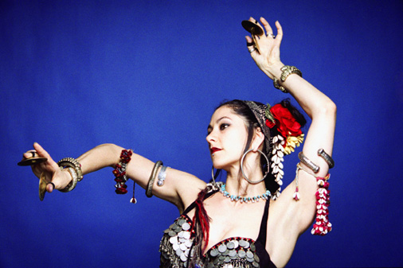
------------------------------

GAINESVILLE DANCE & MUSIC ASSOCIATION
By Dan Lampert

There are a lot of good things happening in Gainesville lately, and here’s one great example… the Gainesville Dance and Music Association (GDMA) has an attractive web site with great information.

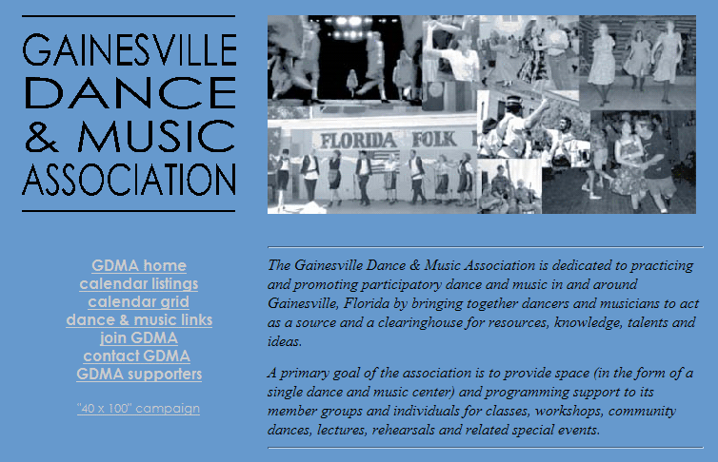
Their web site lists the various weekly dances and monthly dances, from clogging to Irish to Zydeco to Israeli and English Dancing. It’s a must see! Here’s the web address: http://www.afn.org/~gdma/index.html
If you don’t have web access, contact the GDM by email or voice… and tell them you read about the GDM in the FFD! Email: gdma@afn.org or phone 352-219-8907
------------------------------

NEWS FROM GAINESVILLE
by Raluca Ioana Rosca <rarosca@ufl.edu>

[From an email June 6, 2005] On Saturday afternoon in the GDMA building, we had 20 paying participants, 2 children and 2 students (who looked interested in folkdance!) participating in the Doriane's and Yutaka's workshop. WE have some very fun 3 hours, with excellent, energetic teaching and great accordion music. Doriane taught 5 dances (I'm missing one): Circasienne Circle (Brettany), An Dro (Brettany), St. Bernard's Waltz (FRANCE?), a version of Gay Gordons.
Yutaka taught the basic footwork from a region in Ireland and then a 5 parts jig (by that time the lack of sleep the night before caught up with. me, so I can't report too much on those, except 'they looked good').
Both Doriane and Yutaka are fun, excellent teachers, presently based in Florida, and I really recommend them if other groups are interested in their workshops or even for the Florida Camp. They provided music and dance notes, so we should be able to keep their dances.
------------------------------

SARASOTA SMIDGENS
by Marie Millett gvduurn@earthlink.net

[From an email June 23, 2005] Ann Kessler announced tonight that she will be retiring as our teacher this Fall. She has become quite busy with her handwriting analysis and legal documentation. She is retiring only from teaching , but will continue to dance with us. We will miss her teaching but glad that she and Fred will continue to be members of our group. Ann's last official night to teach with us in July, but there will be a recognition party in the Fall.
The Grapevine Folk Dancers continue to dance this Summer but some of us are having a getogether at the Door County, Wisconsin Folk Festival the weekend following the 4th of July. It will be a new event for some of us and a return for others. Nancy Wilusz, Sidney, and Edith Iwens went last year. Dolores Lustig, Don Winnock, Phyllis Spiegel, and I will join this year.
The Millett Hilton welcomes overnight guests who would like to dance with us on Wednesday nights. Call Marie Millett 941-351-6281
------------------------------

SCANDIA WEEK MENDOCINO
by Judith Baizan - judithbaizan@juno.com

[From an email June 27, 2005] Finally at the Scandia Week Mendocino just concluded, Judith Baizan was not the only Floridan in attendance. She was joined by recently confirmed Scandinavian dance enthusiasts Jean and Mike Murray, of Melbourne. Well, Mike Is actually living temporarily in Long Beach, California, but Melbourne is still where he calls home. Since they would be together only for the week of the camp they chose to celebrate their 25th wedding anniversary a few weeks early and invited table mates to join them in a champagne toast to honor the occasion.
The Norwegian focus of this year's Scandia Week Mendocino was on Springleik, with the Odnes brothers, Knute and Ivar, with Ivar fiddling, and Knute and his wife Bodil dancing. At the same time that they wore us out with step practice they kept us amused with their gentle brotherly needling. The Swedish focus was Ewa and Tommy Englund teaching dances from Helsingland, including the wonderful floating Nigpolska. The present practice at Scandia Week Mendocino is to have both Norwedian and Swedish dance represented, rather than alternate them in successive years as was done previously.
Scandia Week Mendocino in California and Nordic Fiddles and Feet at Buffalo Gap a couple of hours west of Washington DC are priorities for Scandinavian Dance enthusiasts. At the first you are likely to be cold, and at the second you might possibly melt. The best partners are to be found at these events, either of them, and our present vision of heaven is to be on the dance floor at both.
------------------------------

TAMPA GRAMPA
By terry.abrahams@verizon.net

[From an email June 25, 2005] That title isn't true - it just rhymes and I always wanted to say it. Tampa Gramma just doesn't do it. Well, Andi is gone, Ursula is back from her trip to the Ukraine where she had a phenomenal time seeing where she was as a child, seeing history, seeing the sights. Now that she is back, she is tending to her tender body, and we're all hoping for a very positive result. Ken Kwo is off to teach at his music camp, Judith has been to CA for a scan camp, the rest of us took care of Ernesto, I'm back from Ft. Lauderdale and the Sunshine State Games, where I also saw my fencing coach and wife and a dance friend in Boca. Our little Jen from our Israeli group is now one of the "friends" at Disney, and loving it. And while all of this is going on, the dancing is slim, but we keep on going! This is my shortest article every - that's because I didn't go on and on about myself - to your relief, I'm sure! Hope I have more to say next month! I'm on my way to Nationals in Sacramento and will make a quick visit to Jerry and Laurie Raz, who will have just finished a Hungarian week and apparently there will be a really good band there, then in August I'll be in
Bulgaria at Koprivshitsa!!!
------------------------------

GAINESVILLE'S INTERNATIONAL GROUP!
by Jack Seltzer - seltzerj@hotmail.com

[Editor’s note: some of this information seems to duplicate Raluca’s article in this issue, but I’m including it because it has other information and another point of view.]
As of June 3rd, the University of Florida Folk Dance group has become the International Dance group of Gainesville.... We've moved off campus for our Friday night dancing.....We have joined the GDMA (Gainesville Dance & Music Assoc.)group of Gainesville and now have a fantastic facility every Friday night from 8 - 11 PM......
It costs each individual $3 a night($1 for students). The charge is to cover the rent and any additional expenses we will incur in the future like a laptop computer or a guest dance teacher.
We're off to a great start for the 1st four Fridays with about 20 people coming each week. The music programming is coming off a computer which Max purchased on Ebay for $100. Now we have 8 - 9 Gig of dances as our collection. What a fun time I'm having setting up the dances for each evening. None of the hassle having to go to individual cassettes or CDs for each dance......
Yesterday Julieta, hosted a yard sale for GDMA and our group and we did great. A bunch of folk from the group; Tina, Rosellen, Toshi, Talia, Jenna, John, Peggy, Eric, June, Esther, and Linda & I were all out under Julieta's trees selling all kinds of stuff for 25 cents to 25 dollars..... Was a fun time until 1PM......
Last Saturday, we all went over to our local Applebees and did our thing cooking eggs and coffee for the GDMA cause.......We all heard it went pretty well but could have been better with all the energy Tara (GDMA's leader) expended on the event. See the following blurb for that event.....
Here's our teaching list....
1) Kortanc - Linda
2) Osmica - Joyce
3) Ma Navu (reviewed) - Jack
4) Lalica (review) - John
5) Kargouna (review) - John
6) Davorike Dajke (review)- Julieta
7) Zumpo Ondo (review) - Julieta
8) Kochari - Jack
9) Belasicko Oro (review) - Joyce
10) Delilo (review) - Margaret
11) Hasapikos (review) – Margaret

All the dances we review will be put on for the request time from now on, as "review" means they have been taught 2 times since we moved to 308. So come on over after 9:30 to do those again.
Other dances put on for "request time" were Korobushka, Zemer Atik, Kissufim, Bannielou Lambaol, Ajd Na Lijevo, AnDro Retourne, Hora Spoitorilor, Djanguritsa, Sweet Girl, Boyash Bypsies, Syrtos, La Bastringue, Elu Tsiporim, Pata Pata, Poslushaite Patrioti(I think it's Russian - a great melody - nice dance, too, that John has kept for us), Rustemul, Arap, Hora De La Gorj, Baztan Dantza, Horehonsky Czardas, 12th St. Rag, Dedo Mili Dedo, Erev Ba, Lum Lum Ley, Blue Bell Polka, Ruby Love(a syrto of Cat Steven's song)… I may have left out some of them.....If anyone cares to add any I missed.......
Any requests, bring them Friday night......We're having a blast bringing back some of these great sounds..... By the way, was fun seeing everyone for breakfast yesterday at Applebees.....Gary really is good at flipping those pancakes......Chimo (Joaquin) also helped in the kitchen and so our coffee came out real steamy and full bodied......(now if only they both can dance as good as they can cook.....)..
Peggy collected $$$$ at the door.....Sherry helped serve the folks who were able to sit, relax and listen to the live sounds of a 3 piece band......These 2 ladies have really given the group a great boost every Friday night.... Now if only their husbands could get on the ball already!!!!! Actually they've all given the group a shot in the arm and they all are getting better at faking more and more of the dances.....
That’s the latest info on our International Dance group.....We're going to have lots of people off and traveling over the summer but we'll keep meeting every Friday....
so give us a call for directions or an email at seltzerj@hotmail.com

FLORIDA FOLK DANCER

Florida Folk Dancer is a monthly publication of the Florida Folk Dance Council, Inc., a non-profit corporation whose purpose is to further knowledge, performance, and recreational enjoyment of International Folk Dance.

2005 FFDC OFFICERS:

President: Terry Abrahams
813-234-1231
terry.abrahams@verizon.net

VP: John Daly
321-951-9623
jbdaly@compuserve.com

Treasurer: Pat Henderson
407-275-6247
henderp@bellsouth.net

-

Return Address
FFDC Newsletter Editor
Post Office Box 151719
Altamonte Springs, FL 32715-1719
USA

FIRST CLASS

Secretary: Jean Murray
321-952-7025
mmurray9496@cfl.rr.com

Editor / Dan Lampert
Historian: PO Box 151719
Altamonte Spgs., FL 32715
dan@webuniv.com

Send all submissions to the Editor during the last week of the month, to be published the first week of the next month.
Copyright: articles in the Florida Folk Dancer are copyright by the Florida Folk Dance Council, Inc., or by their individual authors.
Subscriptions are $15 per year and include membership in the Florida Folk Dance Council. The membership year runs from one Annual Camp (usually February) to the next. Members can receive the newsletter electronically if desired.
For more info: www.folkdance.org

