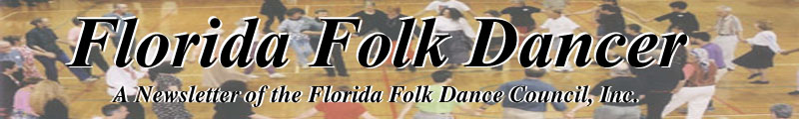
October 2005

PREZ SEZ
by Terry Abrahams <terry.abrahams@verizon.net>
Hello everyone! What a great treat to see everyone at the Fall Fling. A different building, but a great floor, and our hosts were their usual great selves. Everyone outdid themselves on delicious food, only to be topped by the good dancing! I had to leave early to teach Israeli at a Bar Mitzvah, but my hours there were plentiful and wonderful.
Camp business: Between my travels, fencing, dancing and a family crisis, I have tied down Miroslav Marcetic as one of the teachers. He lives in Canada now, but is Serbian and, of course, teaches Serbian dances. The second teacher is not for sure yet, so information on camp will continue to come in dribs and drabs. I have had one person offer to be on the committee to choose menus for camp, and am looking for others, or other, as the case may be. Pat, Bobby and I went to the camp on our way back from Ruthy and Dany’s Israeli camp in GA, and it still keeps us excited!
Speaking of that trip, I drove to P and B’s (no, not peanut butter, Pat and Bobby) on Wednesday, danced with their group who were celebrating a couple of birthdays, we started on Thursday for Atlanta, danced with the International Group that night; I was hosted by Susan Stone, P & B by David Digby. Friday we stopped at the Atlanta vegetable market for Ruthy, and then helped organized treats for the camp when we arrived in the afternoon. They were at a new location and it was fabulous! They are going to keep that spot for next year too. Dany picked his usual good dances, he taught, Ruthy taught, Meliss taught, two kids from G’ville taught – and not a bad dance between ‘em! On our way back to Orlando (Monday nite), we stopped at the Israeli dance to see someone (who was it?) who was back for a visit, danced some more! I left Tuesday a.m. to make sure I was back for our dancing on Tues. nite. Now that’s a great dancing trip!
Th th th that’s all for this time! In the meantime – A Mayim is a terrible thing to waste! So long - Terry
------------------------------

REFLECTIONS ON DANCE
by Dan Lampert [dan@webuniv.com]

Since I started editing this newsletter, which was in March 2003, I’ve asked the recurring question “Why dance?” And over time, I’ve found many good reasons, including “it’s fun”, “it’s good exercise”, and “it’s socially stimulating.” There were many reasons that I stumbled upon, here and there. Sometimes, I found new ideas by directly questioning fellow dancers. However, after a while, I hit a plateau. I wondered if I had exhausted the cosmic list of possible reasons… I wondered where I might find more reasons. Well, the answer was right under my nose.
In August 2005, I was invited by my friend John (who loves swing dancing) to go to a dance event in Tampa. It seemed like a lot of driving, so we resolved to carpool. Once there, I found a large swing dance community, with several lessons per week and a large social dance every Sunday night. When I say “large”, I mean the Sunday social dance attracts 200-300 people!! To get to the point, I met many new people and one of them was a “thinker”. His name is Vinnie, he loves swing dance, and I found myself accidentally sitting near him at the end of a 4-hour dance event. We were both exhausted. There was no chance of further dancing, since the event was winding down, so I floated an idea. I asked him “Why is dancing so great?” He expounded two reasons right away… and both were new to me! I jotted them down immediately…
(1) Dancing builds self-confidence, which helps the individual find success in all areas of life.
(2) Dancing is an interactive learning activity for the mind. Like toddlers, who crave interaction with their environment, we adults can continue to develop our skills for interaction.
So, there it was. Right under my nose. I only needed to meet new people. I know, I’ve been talking about swing dancing, and this is a folk dancing newsletter. However, new ideas about dancing were only a handshake away. With new conversations, I was learning new things, and the “cosmic list” expanded in my mind. If your dancing / exploration brings you in contact with other explanations for “Why Dance?”, please let me know. Write to Dan Lampert in Altamonte Springs, Florida 32715-1719 (you don’t need the box number, they know me well here). You can also send an email to
[dan@webuniv.com].

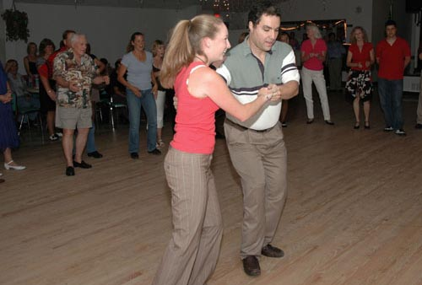
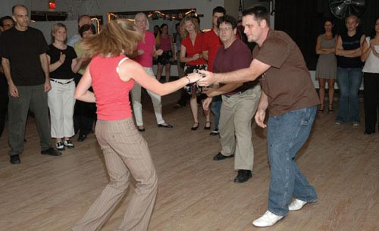

Aug. 28, 2005, a Sunday evening at Zendah Grotto Dance Hall, Tampa, FL
To learn about swing dance in Tampa, go to www.swingang.com
UPCOMING DANCE EVENTS

October
8, Saturday: Oktoberfest, German-American Club in Casselberry (Orlando area)
8, 9, Saturday, Sunday: Greek Festival, St. Augustine
14-16, Friday-Sunday: Greek Festival, Maitland (Orlando area)
29, Saturday: Greek Festival, Lecanto
November
11-13, Friday-Sunday: Greek Festival, Daytona Beach
February 2006
3,4, Friday, Saturday: Greek Festival, Ocala
17-20, Friday-Monday: FFDC Florida Camp, Camp Crystal Lake, Keystone Heights
------------------------------

2005 KOLO FESTIVAL
By Kay James

We received a press release of an event in San Francisco this November. One of our teachers is there: Ahmet Lüleçi. The press release was sent in by Gary Anderson, publicity committee, email: editor@letsdancemag.net phone: 415-488-9197.

54th Annual Kolo Festival Comes to San Francisco
Dance away those Thanksgiving pounds in San Francisco, Friday and Saturday, November 25 and 26, at the Russian Center, 2450 Sutter Street, San Francisco. Classes will start at 9:30 each morning.
This year’s Kolo Festival will feature three singing teachers: Juliana Graffagna teaching an overview class both days, Michele Simon teaching a care and feeding of the Balkan voice class and Rajna Ledoux teaching Croatian singing. There will also be instrument instruction in melody and percussion by teachers still to be announced.
The dance teachers are: Ahmet Lüleçi, Turkish; Erik Bendix, Macedonian and Bulgarian; Marko Vukadinovic, Serbian and Jerry Duke and Bob and Sharon Gardner, Northern Greece.
There will be live music each evening, featuring Anoush, Bebelekovi, Zabava, Zaedno and others. And a concert will be presented at 6:30 pm Saturday, followed by more dancing to live music.
And a feature that has been brought back this year is the opportunity to practice the dances being taught in the studio Saturday night after the concert.
For more information and registration, please see our web site:
www.balkantunes.org/kolofestival or call 1-800-730-5615 or email Jerry Duke at jcduke@sfsu.edu

------------------------------

A QUICK REPORT ON MAINEWOODS FOLK DANCE CAMP, Summer 2005
Sylvia Gruber SylviaRoslyn@aol.com

The atmosphere is warm and gemutllch. Sandy Starkman and her helper elves do a good job keeping things moving along. There is a wood floor. The food is nourishing, satisfying and tasty. Informality reigns. There is lots and lots and lots of dancing. Sandy has promised that by next year, there will be real beds in all of the cabins. Unless you are a male person, between the ages of 7 and 14, do not, I repeat, DO NOT attempt to sleep on the skinny body cots that were mostly available this year. Only male persons of those ages, having run around like lunatics in the fresh air all day could sleep on those things.
This year, my Mainewoods adventure was also a musical one. I played the tambourine in the pick up orchestra. Although I play no musical instrument whatever, I have always yearned to play in an ensemble. You don't have to read notes for that. Anyway, that tambourine was the closest I've ever gotten to realizing that ambition. Unfortunately, there's not much call for tambourines in the Philharmonic.

MEMORIES OF HAL SCHMETTERLING, 1930-2005
(an interview of Anita Schmetterling by Jan Lathi)

Hal was born in New York City on October 26, 1930, to immigrant parents: Bela (Czechoslovakia), and Charles (Poland). During school age, he moved with his family to Brooklyn.
He was 16-17 years old when he met through folk dancing Rose Zimmerman (who choreographed Blue Tango). Hal danced with her, and also the Hermans, Murray Sherman, David Hahn, Irving Caesar, and Dick Crouse.
Hal was quite active in square dancing; he actually called dances.
He attended Brooklyn College, where his original major was in geology. However, he degreed in education. He taught elementary school (4-6 grades) for 32 years in the Plain Edge School District and on the Lower East Side in New York City.
Hal married Anita in 1953 in December. They had three children: Steven (deceased), Andrew, and Lisa. Steven’s death from a blood disorder at the age of 7 was a great loss to the family. Although they were separated about 10 years ago, they were married for 41 years. They were good friends throughout all these years up until Hal’s death.
After retirement, Hal wanted to live in Florida where they moved in 1990. His passions were fishing, dancing, gardening (especially orchids), and some travel. He was a member of the Audobahn Society, the Palm Coast Orchid Society, and the Florida Folk Dance Council.
He was an avid reader – especially liked Clyde Custler and James Michener and, of course, fishing magazines.
Hal loved all things to do with nature. He learned to play guitar in his teens and played many folk songs. He lovingly shared his talents with a multitude of friends, students, and family, more often than not, touching their lives in meaningful unforgettable ways.
Hal Schmetterling (which means butterfly) was well known for flitting from one activity to the next, and one neighbor to the next. He was a people person and couldn’t do enough for his friends and acquaintances.
His favorite dances included Jarabe Tapatillo, Zillertaller Landler, Polish Polka, Contra Dances, Krakowiak, Kujowiak, Alexandrovski, Israeli Mazurka, Veleta, and Svend’s Hambo. Perhaps when you next execute one of these dances, you will remember the kind human being and lover of the dance who was Hal Schmetterling. Hal passed on to dance on another floor on March 16, 2005.
Hal’s ashes were brought up to Long Island this summer and were strewn at a favorite fishing spot of his.

The Butterfly (by Anita Schmetterling)

In his garden he grew
along with hydrangeas, orchids and lilies.
As he walked his path, he pruned, talked, and played
Music for them.
They honored him with their beautiful blooms.
While tending them, he grew in kindness, love,
Generosity and patience.

They took him from the caterpillar stage; slow
Moving and steadfast.
To a dormant time when he went deeply within himself.
Preparing to emerge in his own way, in his own time:
A multi canvas of color and design
The Butterfly

He flittered from one garden to another, the gardens
Of his friends.
Offering cuttings from his plants.
Brazenly cutting back their shrubs.
But they bowed to his expertise
For they dearly loved the visits of “The Butterfly.”

FLAGLER BEACH
from Jan Lathi
amarjan@bestnetpc.com

We have been dancing all summer, even though some of our “snow birds” have flown north for a bit, but we have welcomed into our midst Arleen Kaufmann, who has a summer home in Flagler Beach.
I had an exciting trip up north this summer which included visiting relatives in New Jersey and Boston, a session at Mainewoods Dance Camp, a visit to Circle Lodge in Hopewell Springs, NY, to visit an old friend, Elizabeth Konviser, who teaches folk dance there every summer, and a trip back in time to Syracuse, NY, for my 50th high school class reunion. Would you believe that 2 weeks prior to the reunion, Solvay High School was torn down? On each table at the Saturday evening dinner, a golden brick from the school held down our celebratory balloons! I had lunch with Kay Demos, who comes to our camp, and who, incidentally, has purchased a home in Tarpon Springs, FL where she will live for the winter months. Barring health issues with her knee, she plans to return to Florida Camp. I also visited my old dance group, the Morristown Folk Dancers while in NJ. One of those dancers, Rhoda Roper, is a good high school friend of Fanny from the Melbourne group! Small world!
It was so good to see everyone who attended the latest “Fling”. The wooden floor surely makes a difference, as will the new camp floor. The Melbourne Mob were as gracious as ever and we four from Flagler Beach/Palm Coast enjoyed the day and the dancing. Thank you John and gang!
I have booked a brief cruise to Nassau on Feb. 14-19th and I am afraid that Camp will be the weekend I am away (I was counting on camp being the last weekend in February) so I may have to miss it (or most of it) this year. Nuts and bolts, anyway! I hope to get there for a day at least. I want to check out that wood floor!
We still dance on Thursday afternoons 2-4 and hope any of you would join us some time.
Oh, the NEWS in my life is that I have adopted Sami (Samantha), a lab/hound mix dog from the Humane Society. This poor dog had been mis-treated (Benzine poured on her and lit) and is quite severely scarred but we love each other and that is what counts. We are slowly learning much about each other and bonding is taking place in a big way. I am loving it!
------------------------------

DANCING ON THE WATER
By Bobi Ashley

With special folk dance events scheduled at every port, the cruise ship M/S Dalmacija carried Mel Mann's group of ninety folk dancers to seven lovely "Pearls of the Adriatic," June 11-18, 2005. Dance teacher and leader, Lee Otterholt, has led many "Dance on The Water" cruises. An international folk dance figure, Lee knows many dance leaders in Europe, and arranged special dance events at each port in addition to his own teaching.
The first pearl visited wad Korcula, a charming old town considered the birthplace of Marco Polo. One could visit the house where he was born, and climb a tower for a birds-eye view of the medieval town and the Adriatic Sea. Back at the ship, we learned Croatian partner dances taught by local performers.
The next pearl, delightful Dubrovnik, offered the most spectacular performance of the trip. On an outdoor stage at the edge of the harbor, the "Lindjo Ensemble" of fifty performers gave a forty-five minute private show that will be long remembered. Later we were treated to a two-hour lesson, dancing with members of the Ensemble to live music. What more could a traveling folk dancer wish for?
On the Greek Island of Corfu, we toured the Achillion Palace and a monastery. The palace, surrounded by elegant, colorful gardens dominated by a huge statue of Achilles, is the former summer residence of Austrian Empress Elisabeth. The monastery, situated on cliffs high above the beautiful beach village of Paleokhasastritsa, has spectacular views of the coast and the glistening turquoise Ionian Sea. In the evening, two couples performed traditional and contemporary Greek dances on the ship, and led us in line dances.
The fourth pearl on our itinerary was Kotor, in Montenegro. According to our tour guide, it is located on "one of the 25 most beautiful bays in the world." Kotor was an interesting surprise with its protective four-kilometer long wall and battlements. Eight lovely ladies from the "Bernice" group came to our ship in the evening to sing and perform a dance done by wives of sea captains for many generations.
The fifth pearl, Split, began 1700 years ago as a palace for Diocletian, last of the Roman Emperors to persecute Christians. Ironically, his mausoleum was turned into a cathedral; and his temple to Jupiter became a baptismal. It began to grow into a town in the seventh century, when inhabitants of the nearby town of Salona took refuge in the palace during the invasion of the Avars and Slave. Outside the palace walls is a large open-air market where a great variety of vibrant colors, pungent odors, and interesting interactions between buyers and sellers were there "Jedinstvo" taught a formation style dance from Split.
The outstanding feature of Pula, our sixth pearl, is the coliseum. Smaller than the one in Rome, the people of Pula consider it to be more beautiful. Built in 1 AD, a local legend has it that the coliseum was built in honor of a beautiful slave girl. After our tour, some of us climbed to a hilltop tower with an excellent view of the whole area. That afternoon, on board, we had a Croatian dance performance and lesson with live music, by dancers from the fold dance ensemble "Cere."
The most beautiful pearl was saved for last-Venice. We took a water taxi tour of Venice by night that was magical. Cruising the Grand Canal we viewed palaces built over a period of five centuries. Lit up like a Christmas tree, the town was reflected in the busy waters where gondolas bobbed as water taxis sped by. St. Mark's Square was amazing with street artists, colorful shops, sidewalk cafes and live music in all places.
Curious for some time about Mel Mann's cruises on the water, the trip was all I had hoped-and more. The group was a wonderful mix of folks from many places, some experiencing their first sailing with Mel, while others had as many as twelve trips with him. It was nice that we had most of the day at the ports-not just a couple hours. The best part of traveling by ship is that we only unpacked and packed once. That left a lot more time for dancing and sight seeing.
For more information about yours, visit the Website: folkdanceonthewater.org
------------------------------

GRAPEVINE INT'L FOLK DANCERS OF SARASOTA
by Marie Millett gvduurn@earthlink.net
We welcomed Andi Kapplan back from Vancouver on September 14 and she started her first night as our teacher with 25 enthusiastic dancers. A pretty good number for September. As you can see by our picture, the newspaper gave us some great publicity. We've had five new people out as a result. They all came to see what was so interesting about my feet.
We're looking forward to the retirement party for Ann Kessler on November 2 and welcoming Nancy Wilusz back from Minnesota.
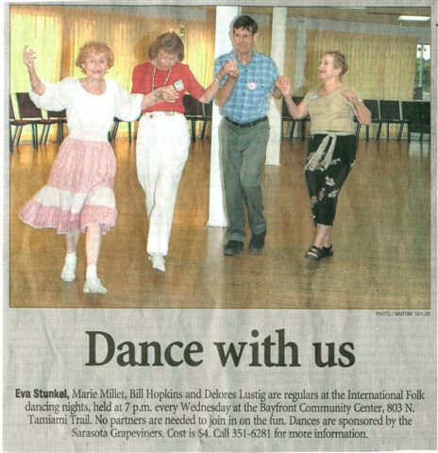

From the Sarasota Herald Tribune on Sept. 5, 2005
This news caused 4 new people to attend the next meeting!
ORLANDO INT'L FOLK DANCE CLUB
By: Pat Henderson, henderp@bellsouth.net

We resumed dancing on September 7 and danced every Wednesday in September for the first time in years. We usually get rained out at least once. We enjoyed our reunion and finding out what happened with each other over the summer. In medical news, Joy Herndon is responding to physical therapy on her knee and is not planning replacement surgery at this time. Juanita Schockey is planning on hip replacement surgery later this year so she can recover in time for camp. Many dancers traveled over the summer. Joe and Lucy Birkimeier spent time with family and vacationed in Washington D.C., the West Virginia mountains, Chicago and Buffalo. Phyllis Dammer and her husband enjoyed a trip to Copenhagen for 5 days and then a Baltic cruise to Estonia, St. Petersburg, Sweden and Finland. She danced with performers in Estonia and saw a dance performance in St. Peterburg. After that trip and being home a short time, they spent a week in the White Mountains of New Hampshire and rode a cog railway, the first in North America. Bobby and I traveled to the north Georgia mountains for an Israeli workshop with Dany Benshalom. Terry Abrahams rode with us and we stayed in Atlanta in time to dance with the Thursday night group. We enjoyed seeing David and Dorothy and the other Atlanta dancers. As I write this, Juanita Schockey and Ann Robinson along with their husbands are in Branson, Missouri. The group trip was organized by Ann and her husband, Danny Robinson, a well-known Orlando square dance caller. In October, the club is having two parties, the first will probably be history by the time your read this. Bobby is turning 60 on October 5 and we are celebrating during our regular dance session. Then, on October 26, we are having our annual Halloween party with international or Halloween costumes galore. We hope to have pictures in the next newsletter.

NEWS FROM GAINESVILLE
by Joyce Dewsbury, joysong@ufl.edu

After leading the International Dance Group of Gainesville (formerly the UF International Folk Dancers) Raluca has left Gainesville for her new teaching job. Raluca did a tremendous amount for our group. She was there almost every week without fail setting up the music, organizing teaching and the teachers, going to meetings with the Sports Council and Student Government, organizing workshops, and generating enthusiasm and energy into our group. She helped to keep us going when many of us were in all honesty too busy. She kept our group from becoming a dusty memory.
It was Raluca and Toshi who went to the initial meetings of the embryonic Gainesville Dance and Music Association (GDMA). Tara was the dancer who had the vision of gathering together the small dance groups in town who needed a space in which to dance. The GDMA became a reality with the rental of the second floor of a building in downtown Gainesville. There are two dance spaces both with wood floors. There are several smaller rooms one of which is a playroom for children.
After having to leave Norman Hall Gym, where we had danced for many years, our group danced in two different locations on campus. There were problems with each and gradually our group was made to feel unwelcome on the UF Campus. Therefore, it was very fortuitous when this other dance space became available. We joined the GDMA and are very pleased to be a part of this umbrella organization.
Jack Seltzer has already written about our beginnings in our new dance home in the July/August 2005 issue of the Florida Folk Dancer. We continue to have a wonderful time. Since we began dancing there on June 3 we have taught over 100 folk dances. Folks can't seem to get enough of learning dances. It is not unusual to have ten to twelve dances taught each Friday night. Besides the nice wood floor we have ample parking, the building is easy to find, and everyone from the community is welcome. We have already had some new folks join us and we are confident that our group will grow as people learn about our attractive new location.
------------------------------

Well the "Times they are a changin." And here's the summary as Dylanesk as I can make it. Just try not to sing my verses like Bob Dylan might have.
Last June we left Weaver Hall on the UF campus as the many inconveniences of the room we danced in were too numerous for us to maintain a regular group. We persevered over having columns in the middle of the room to having to call on a cell phone for admittance to the room. But we did it for a year with Raluca giving all her energy all the time. She was invincible!!!! We all owe her our thanks for an endless job, well done.
A timely opportunity to leave our UF confines for the local Gainesville dance community was developing with the help of Toshi Nishida & Raluca. As many as 10 - 15 different groups dancing all over the place were beginning to organize to find 1 roof to be under and 1 wood floor to dance on.
So GDMA , short for Gainesville Dance & Music Association, was formed. Tara Bolker, a Morris and English dance teacher, had organized all the different leaders, for an extremely reasonable fee, to come and dance different nights of the week. Well there we were, and we got our traditional 8 - 11 time slot on Friday nights.
Boy, were we happy. Now we could dance on a suspended wood floor all night and not have to be bothered by avoiding columns and unexpected cell phone calls. It all became so much easier to be able to park right under the building at 308 University Avenue(probably the only building in Florida where you get to park under your dance floor).
Anyway, now we're off and running. Slowly but steadily we're bringing in new folk. Each night we begin at 8 with as many fun beginner dances as our high charged group can think of. And we're becoming high charged again with as many as 12 - 15 dances taught and 35 - 40 dances done during the night until 11.
We're lucky to have some great teacher leaders here in Gainesville. Joyce Dewsbury and John Ward are always there with their unique teaching style and high quality dances. They are certainly the roots of folk dancing in north Florida. Always bringing out some old new ones for us to bring back and carry on. They're never ending with their repertoire.
Margaret Tolbert is as unending as anyone I've ever seen. Another folk who can go back and constantly dig up another phenomenal high powered step or 'hold' in the middle of a step. Every Greek, Romanian, or Turkish sound has her in high gear moving all over the floor.
We can go on and on about these great dancers but you've just got to come on out some Friday night when you're in or around Gainesville and see for yourself. We have arrived now in Gainesville and we're ready for anyone and everyone.
By the way, I'd better mention that Linda & I do have fun teaching some odds and ends to keep the flow on the go. These past 2 weeks, I brought back "High Life" a Ghanan dance which John Semmelow brought to us in Norman Hall about 10 years ago. It's gotten me back into swimming all the time since we're constantly doing 12 swimming steps near the end of the dance.
Also remember we have Julieta Brambila who is always giving us a lift with her light stepping beats to the music. We always think we can relax with her tunes but then we realize the next week, how subtle her footwork could be in each of her dances.
Anyway some our new faces over the past few years are constantly giving us great support. There's Randy Thorp and Stefan Craciuns, to name just a few. Boy, you should have seen Stefan trying to drink some liquid out of a small glass on the floor during his Greek interpretation of how it's done. Randy is ready to start teaching some of his favorites one of these nights. He's enthusiastic.
Anyway, the news of folk dance camp up here at Camp Crystal has all of us thinking of our kids who went to either day-camp or sleep over during the years. It's going to be a great site and I'm hoping we can bring a big contingent from this neighborhood. Having camp over President's Weekend again was a great idea, as now it will be more conducive for our students and teachers to be more involved for more of the 3 day weekend.
Happy trails to ya......Jack Seltzer
------------------------------

THE TAMBURITZANS
by Bill Schwarz [WBILLSCHWARZ@msn.com]

The Tamburitzans of Duquesne University will perform at the Tarpon Springs Arts Center (just North of Clearwater) on Wednesday, Jan 4 and Thursday March 9th, 2006 at 7:30 pm. Tickets are around $20 and sell out. Box office (727) 942-5605.

Here is the full 2006 schedule of Florida performances for the Tamburitzans:
Date |  | City/State |  | Venue | Time | Contact
Wednesday January 4 |  | Tarpon Springs, FL |  | Tarpon Springs Performing Arts Center | 7:30 PM | Tickets  727-937-0686
Thursday January 5 |  | Del Ray Beach, FL |  | Huntington Pointe Club House | 8:00 PM | Huntington Point Association
Friday January 6 |  | Lake Worth, FL |  | Palm Beach Community College/Duncan Theatre | 7:30 PM | D.U. Tamburitzans 877-826-6437
Saturday January 7 |  | Lake Worth, FL |  | Palm Beach Community College/Duncan Theatre | 7:30 PM | D.U. Tamburitzans 877-826-6437
Saturday January 14 |  | Panama City, FL |  | Marina Civic Center | 7:30 PM | Joyce Harrison 850-236-1260
Sunday January 15 |  | Melbourne, FL |  | EAU Gallie High School | 8:00 PM | Box Office 321-242-2219
Saturday  March 4 | Crescent City, FL |  | George C. Miller Middle School |  | 7:00 PM | Jean Labonte 396-698-2342
Sunday March 5 | North Port, FL |  | North Port High School |  | 3:00 PM | Mary Maples 941-426-8479
Monday March 6 | Lakeland, FL |  | Florida Southern College - Branscomb Auditorium |  | 7:30 PM | Box Office  863-680-4296
Tuesday March 7 | Avon Park, FL |  | South Florida Community College |  | 7:30 PM | Box Office  863-453-6661
Thursday March 9 | Tarpon Springs, FL |  | Tarpon Springs Performing Arts Center |  | 7:30 PM | Tickets  724-937-0686
Friday March 10 | Sunrise, FL |  | Sunrise Civic Center Theater |  | 7:30 PM | Box Office  954-747-4646
------------------------------

CRUISE OVER THE WINTER HOLIDAYS
by Sara and Jim Osborn, Georgia [JSosb2@aol.com]

Many of you remember Sandy Starkman , folk dance teacher from Toronto, director of Maine Camp, and a teacher at the Florida camp four years ago. She will teach folk dancing on the new Semester at Sea cruise ship (just 5 years old) on a trip through the Panama Canal, . Let me quote from a recent e-mail from her:
“ When I got home from Romania, I had an email (from Tiffany) asking me to organize a folk dance group and they gave me until almost sailing time to do it. I need 10 people which I almost have but would like more folk dancers to join. If we get 15 people, then everyone gets a 10% discount. We will teach the other passengers to dance and then have our own sessions. It is from Dec. 28, 2005 until Jan. 12, 2006...If people are interested they could call or e-mail me at 416-633-4852 or sandydancing@juno.com or call Tiffany directly at 1 800-854-0195.”
Jim and Sara took a similar trip four years ago, over Christmas, on the Semester at Sea ship, The Universe Explorer. It was a great trip. This time the trip will include stops in: Cabo San Lucas and Huatulco, Mexico, Guatemala, Costa Rica, Panama, Colombia, Jamaica, Georgetown Cayman Islands) and finish at Ft. Lauderdale. Those of you who have been on a Mel Mann Dance on the Water cruise to Alaska, or one run by Karl Finger, can attest to the uniqueness of the Semester at Sea cruise ship--the entertainment, library, and especially the excellent pool of professors of different specialties who offer the lectures. Go if you possibly can!
------------------------------

GEORGIA RANG TANG
Save the weekend of April 7-9, 2006 to come to Atlanta for the 33rd Georgia Rang Tang. Liz Nunan is negotiating with a teacher of Armenian dances and musicians. More information later.
------------------------------

THE COMPUTER SWALLOWED GRANDMA

The computer swallowed grandma.
Yes, honestly it’s true.
She pressed 'control' and 'enter'
And disappeared from view.

It devoured her completely,
The thought just makes me squirm.
She must have caught a virus
Or been eaten by a worm.

I've searched through the recycle bin
And files of every kind;
I've even used the internet,
But nothing did I find.

In desperation, I asked Jeeves
My searches to refine.
The reply from him was negative,
Not a thing was found 'online'.

So, if inside your 'Inbox,'
My Grandma you should see,
Please 'Copy', 'Scan' and 'Paste' her
And send her back to me!


T-T-T-TAMPA!

Well, we just had a great 2 Fridays in a row! Last week we had Kevin Johnson revisiting (while he tied up some lose ends with his paper), Bobby Ward, Maria Pasetti, Ken Kwo didn’t have any rehearsals, our usual 5 were there, so we had enough for a real circle! And then came this week! Evelina was here in the states visiting – she had a conference, and from there is taking time to see old friends. She joined Judith on Wednesday and the Tampa International group on Friday. Because of her presence, Kevin (of Kevin and Nilifur) came after 15 years of not coming, Dylan came at the very end (he didn’t dance), two of her friends from work. Then Judith had 4 people come for the first time, a guy named Bill came from contra that has never come before, Maria came again (albeit with a very sore foot), Kathy and Jim came with Evelina. This time we didn’t have Andy and Susan, but even without them, we had 18 people!!! And gender balanced at that! Between Andi, Judith and I, we kept things hopping with good beginner dances, now and then taking a little break to show them the possibilities of more difficult dances, and a GREAT time was had by all! Some of us went out for food afterwards, and it was like old times. We also went out the week before to celebrate Ken’s and my birthdays (the 23rd). Andi’s was this Fri, but she was expecting a call from her kid, so didn’t come with us. Anyway – I can’t stop thinking about how wonderful it was!! I took a picture as proof and am enclosing it here.
Ursula is finally in touch with some of us. She had her back surgery, went on to a rehab joint, and is now home, using a walker and coming along. We all wish her the very best kind of recovery, as we miss her at the dance sessions. Bobby, Barbara and my fencing coach did a dancing/fencing demo at a nursing home. We’re ready to go on the road! My teach at the Bar Mitzvah went well; I think I got another job out of it, but alas – no takers for our group (which is always the hope, right?) Andi is back from Canada, Ken is back from camp and all is well with the world. I’m leaving out all my personal stuff to give you all a break this month!
See ya! T A
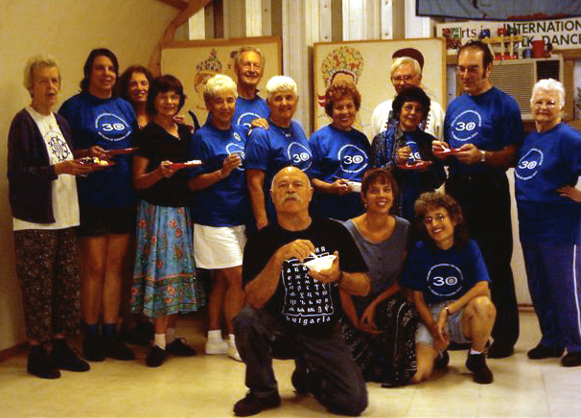
Orlando birthday party (not Bobby's - the one before)

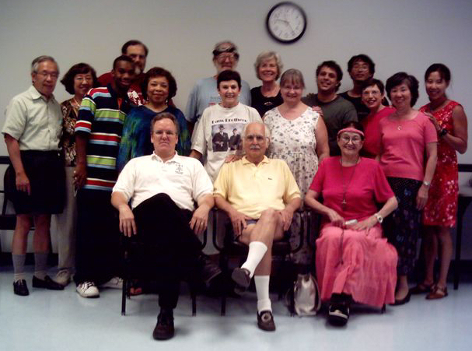
Group shot of the fabulous Friday night in Tampa.

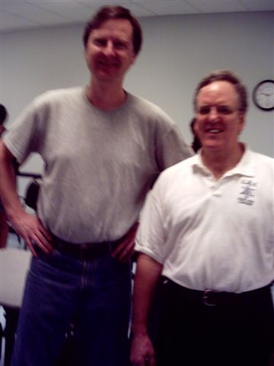
Proof that Dylan and Kevin were there!

FLORIDA FOLK DANCER

Florida Folk Dancer is a monthly publication of the Florida Folk Dance Council, Inc., a non-profit corporation whose purpose is to further knowledge, performance, and recreational enjoyment of International Folk Dance.

2005 FFDC OFFICERS:

President: Terry Abrahams
813-234-1231
terry.abrahams@verizon.net

VP: John Daly
321-951-9623
jdaly@palmnet.net

Treasurer: Pat Henderson
407-275-6247
henderp@bellsouth.net

-

Return Address
FFDC Newsletter Editor
Post Office Box 151719
Altamonte Springs, FL 32715-1719
USA

FIRST CLASS

Secretary: Jean Murray
321-952-7025
mmurray9496@cfl.rr.com

Editor / Dan Lampert
Historian: PO Box 151719
Altamonte Spgs., FL 32715
dan@webuniv.com

Send all submissions to the Editor during the last week of the month, to be published the first week of the next month.
Copyright: articles in the Florida Folk Dancer are copyright by the Florida Folk Dance Council, Inc., or by their individual authors.
Subscriptions are $15 per year and include membership in the Florida Folk Dance Council. The membership year runs from one Annual Camp (usually February) to the next. Members can receive the newsletter electronically if desired.
For more info: www.folkdance.org

